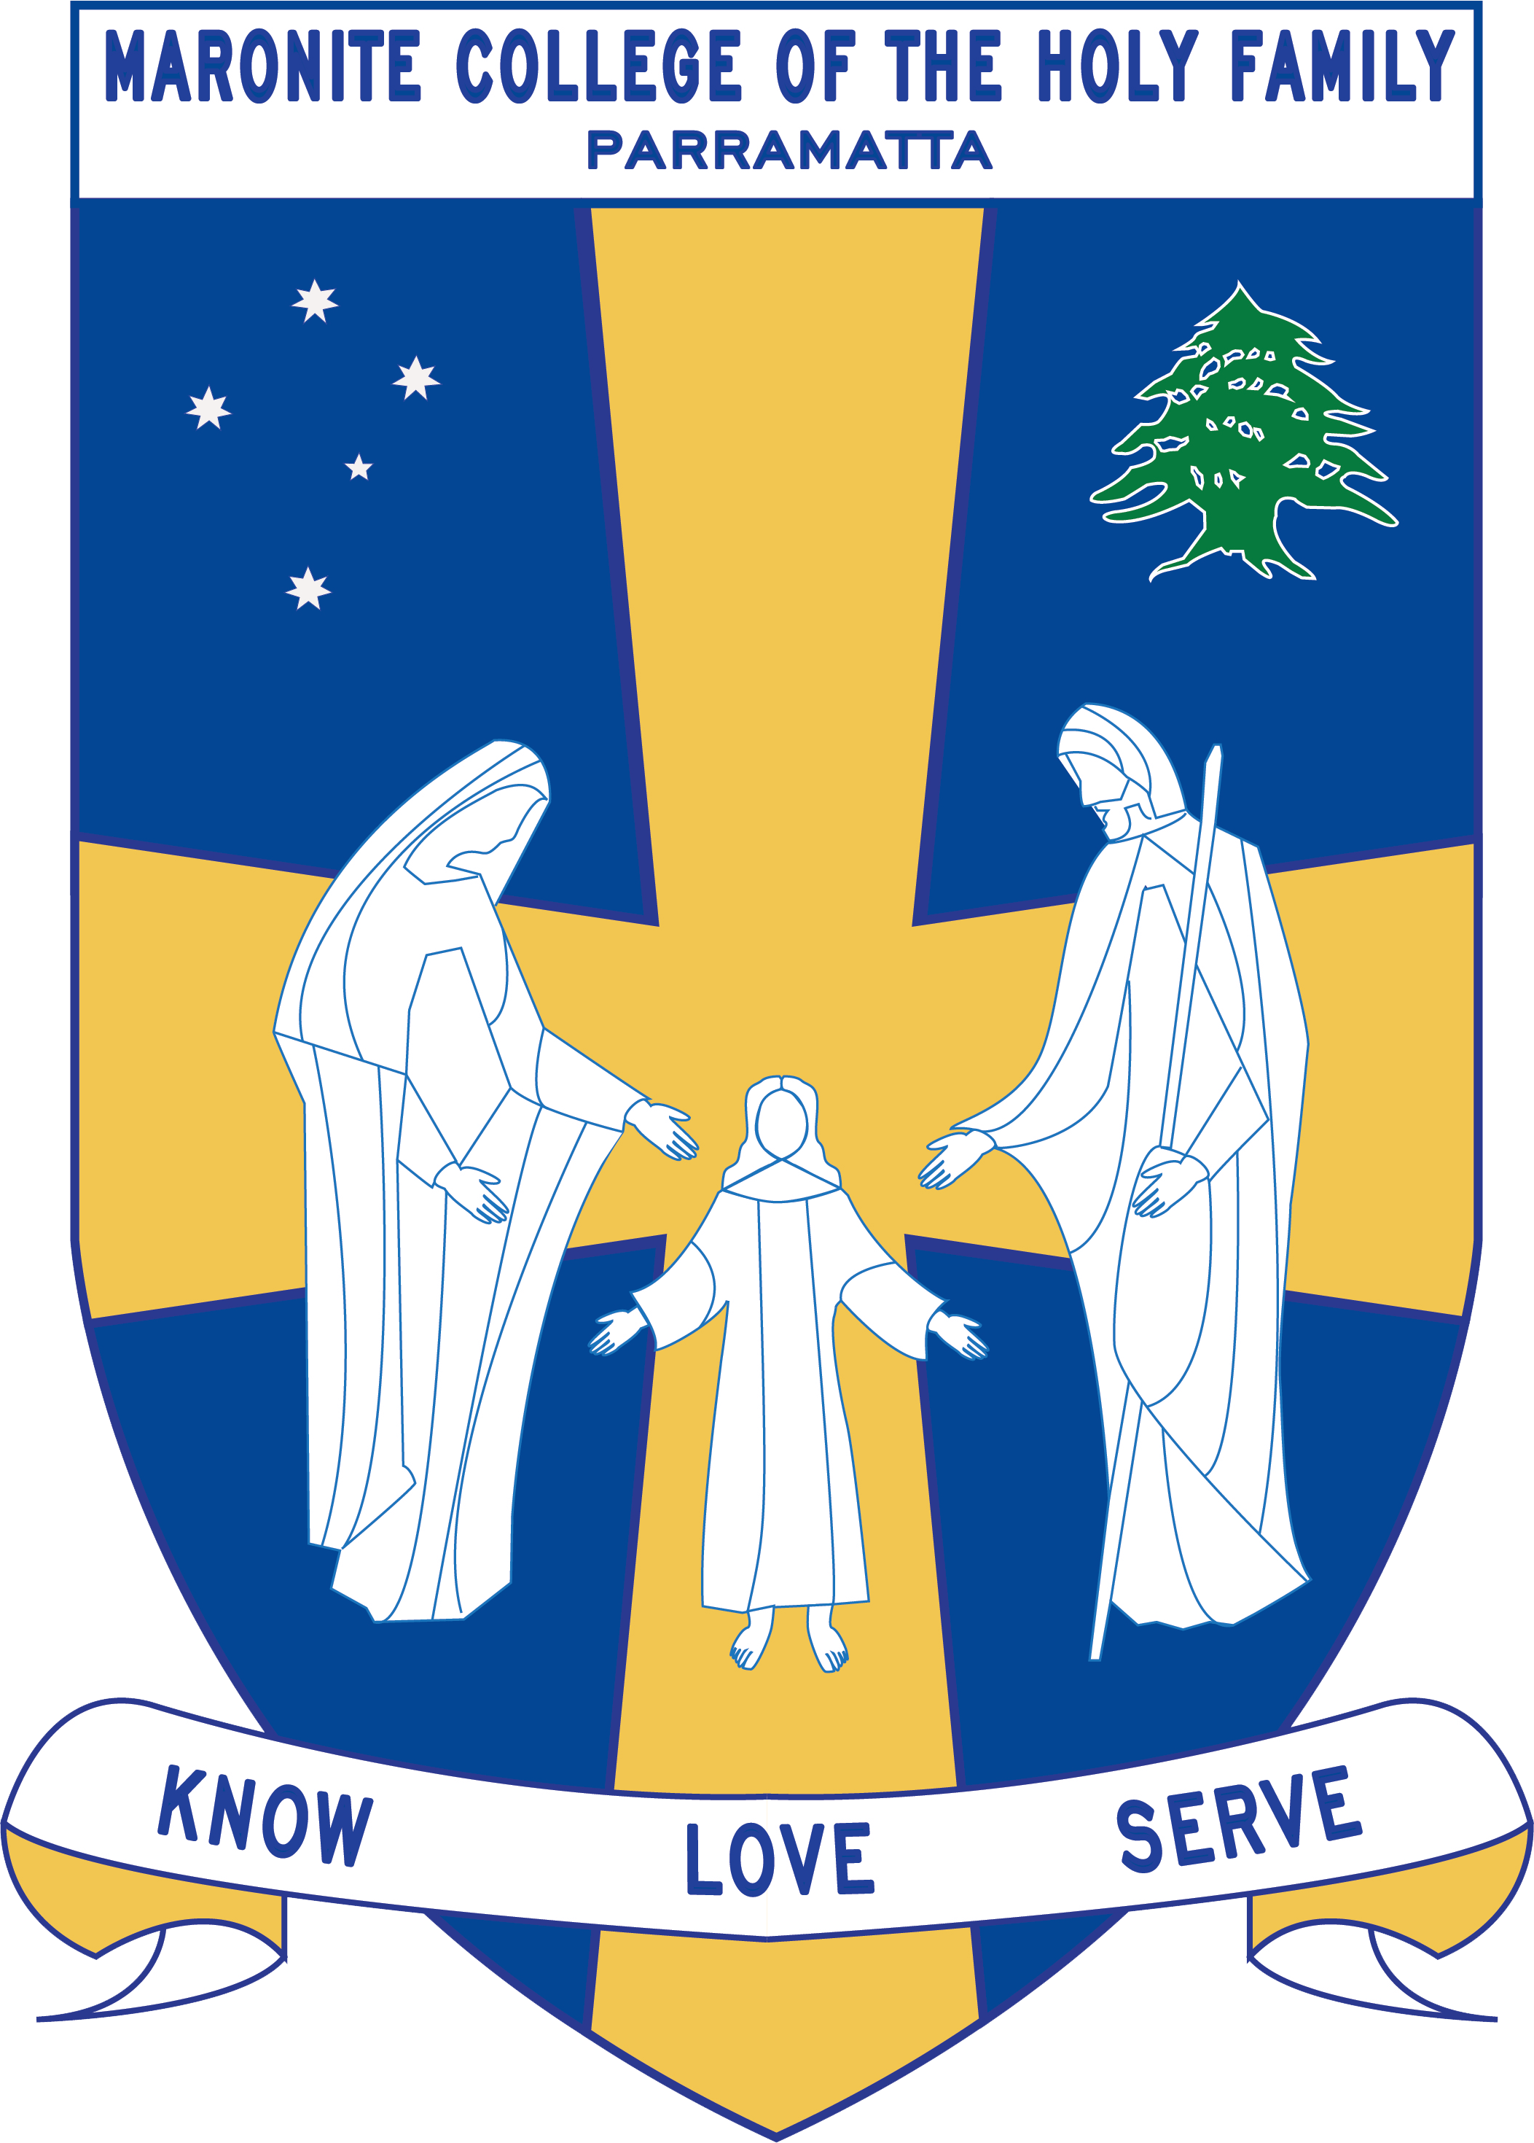
Maronite Sisters of the Holy Family
Maronite College of the Holy Family

23-25 Alice Street Harris Park NSW 2150; Tel (02) 9633 6600 Fax (02) 9689 1662
Email: admin@mchf.nsw.edu.au Web: www.mchf.nsw.edu.au
Maronite College of the Holy Family

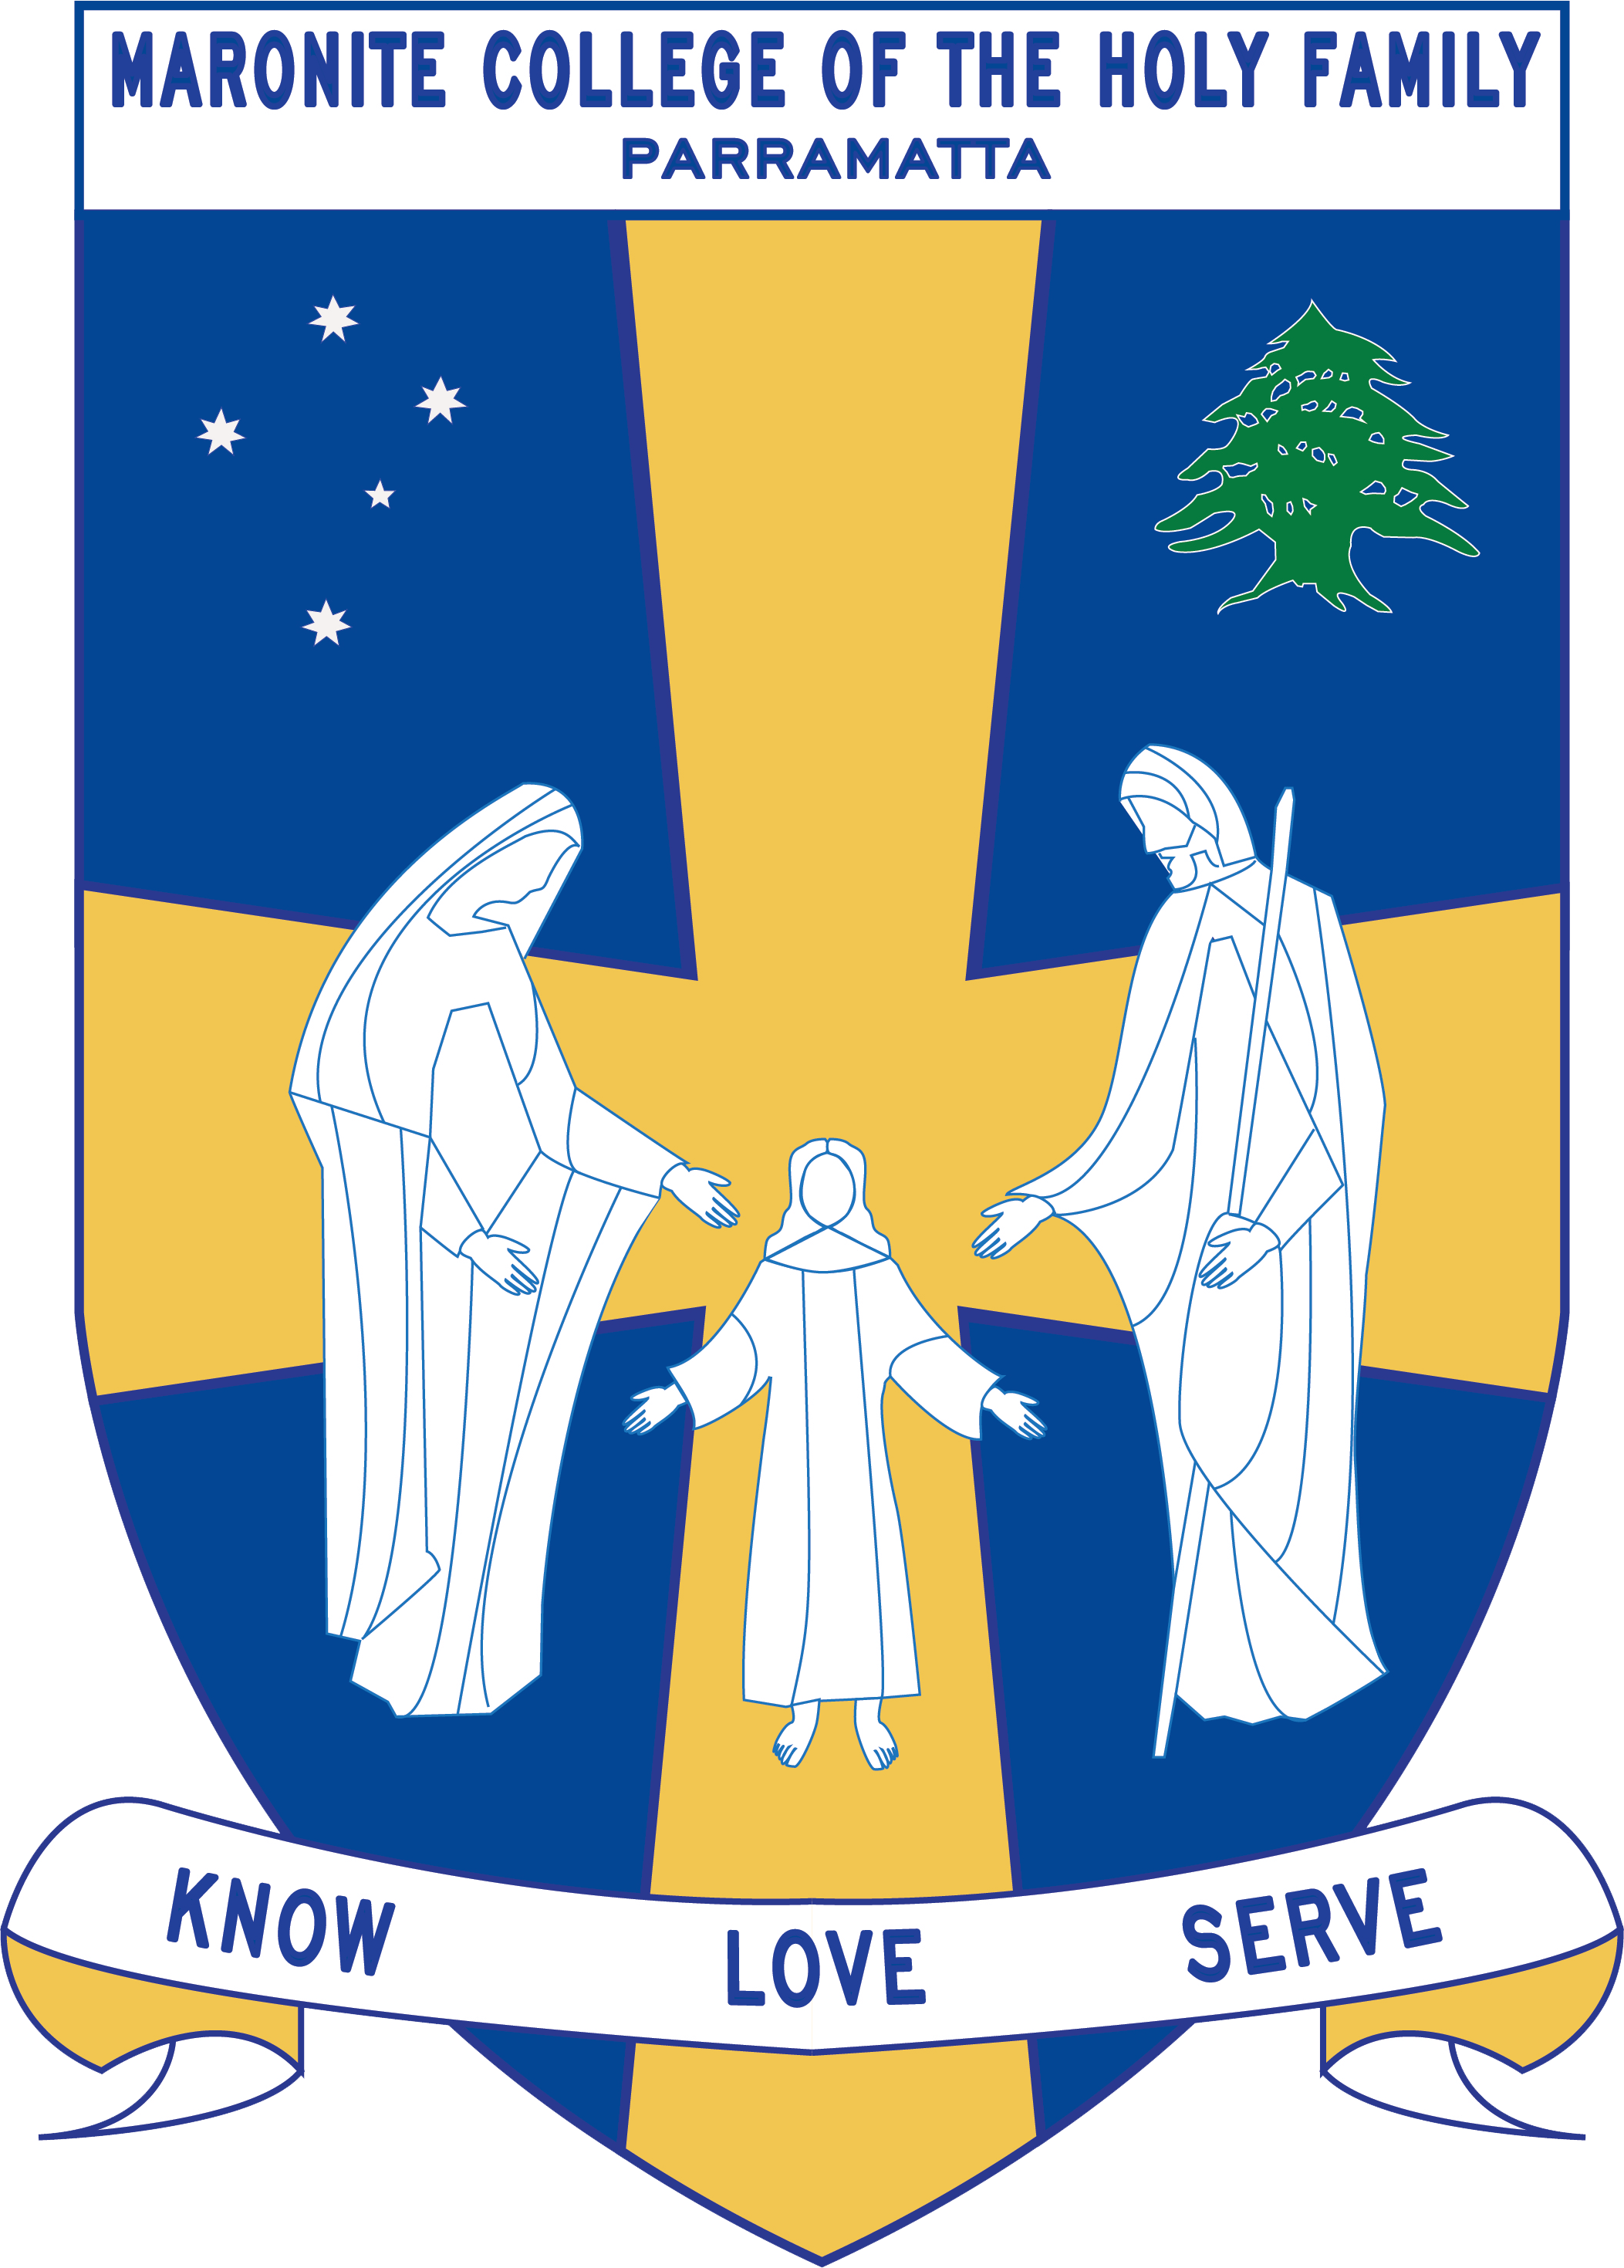

Grade Curriculum Notes: Year 4

2017
Teaching Staff

Grade: Year Four

Grade Teachers: Ms Doumit
Mrs Ramsey
Mrs Pather
Mrs Lal

Integration Teachers: Mrs Maxwell / Ms Wang

Stage Coordinator Mr Day
EAL/D Teacher: Mr Day
Ms Achmar

Teacher Support: Mrs Ghabache / Mrs Nehmer

Arabic Teacher: Mrs Zaiter
Mrs Sassine
Mrs Farah
Mrs Chalhoub

Learning Centre Supervisor:
Ms Roumanus

Curriculum Notes
Homework:
Your Year 4 child should be spending 40 minutes on homework each night. Homework tasks will include the following each week.

- Spelling words
- Dictionary meanings
- English activities
- Mathematics activities
- Reading
Perfect homework reward:
Term 1: To be decided by class.
Term 2: To be decided by class.
Term 3: To be decided by class.
Term 4: To be decided by class.
NOTE: Students who have a 100% home completion rate will be rewarded within their classrooms.
English/Mathematics:

 | Term 1 | Term 2 | Term 3 | Term 4
English | The Key Learning Areas of English is divided into Reading and Viewing, Writing and Representing, Speaking and Listening, Spelling, Responding and Composing,  Grammar, Punctuation and Vocabulary, Thinking Imaginatively, Creatively, Interpretatively and Critically, Expressing Themselves and Reflecting on Learning. It is envisaged that the Year 4 program will assist in the development of the student becoming more proficient in the four areas.  Reading and Viewing: Reading occurs in all Key Learning Areas. During the literacy blocks, skills, strategies and knowledge to read, view and comprehend a wide range of texts will be integrated with texts in different media and technologies. Students will be supported by Mrs Maxwell, Ms Wang, Mrs Gabache/ Mrs Nehmer and Mr Day during reading lessons.  Writing and Representing: Each week the students will participate in writing activities. Revision will take place, as well as improving the students’ knowledge of the types of texts. Grammar, structure and punctuation will be a key focus.  Handwriting: Students participate in handwriting each week using the ‘New Improved Foundation Handwriting’ text book. The students will practise the NSW foundation style of handwriting.  Spelling: Spelling is based on the quota spelling system with a maximum of 20 words. Students complete weekly activities and are tested each week on Thursday.  Speaking and Listening: Speaking and Listening activities are integrated across Key Learning Areas of the curriculum. Children are encouraged to listen to instructions, information from peers. This will include oral presentations.  Responding and Composing: Students develop an understanding and apply knowledge of language forms and features. Students also respond to and compose texts.  Grammar, Punctuation and Vocabulary: Students are given a variety of activities related to shared reading texts. It is also integrated into all other key learning areas.  Thinking Imaginatively, Creatively, Interpretatively and Critically: Students engage personally with the text, develop and apply contextual knowledge, understand and apply knowledge of language forms and features. They also respond to and compose texts.  Expressing Themselves: Students identify and consider how different viewpoints of their word, including aspects of culture, are represented in texts.  Reflecting on Learning: Students recognise, reflect on and assess their strengths as a learner.
Mathematics | Number and Algebra, Measurement and Geometry and Statistics and Probability are all covered throughout the year. Students will be assessed after each topic is covered.  Working Mathematically – This strand is integrated into the content of all areas of Mathematics.
Integrated Units:
 | Term 1 | Term 2 | Term 3 | Term 4
Religion | 1. Talking & Listening to God  2. Lent: A Time for Reconciliation | 1. Easter Season: New Life and experiences of death  2. The Resurrection  3.Key symbols and structure of the Mass | 1. The Bible: A Special Book. | 1. Mission: Serving Others with Jesus.  2. Christmas: A Time to Gather.
History/  Geography/  Science | First Contacts | Science –Living Things | Geography- The Earth’s Environment | Science – Earth and Space
 | The students attend a lesson in the computer room once a week for 60 minutes with their class teacher.
Creative Arts | Visual Arts  - Aboriginal Instruments  Drama  -Perform your own ending  Music  -Beat, Rhythm, Dynamics, Tone, Texture and Tempo | Dance  -Dance Around the World  Visual Arts  -Picasso & Fruit Bowl Painting  Drama-Integrated with Religion- St Peter and St Paul | Visual Arts  -Perspective  Drama  -Charlie and the Chocolate Factory  Music  -Music Features and Notions | Dance  1.Dance maps and choreography  2. Visual Arts  Van Gogh
PDHPE  Sport day- Tuesday | PD/H Active Lifestyle  PE: Newcombe Ball  Swimming | PD/H Personal identity – Recognising growth of self and others  PE: AFL Athletics Carnival preparation | PD/H Personal health choices and making decisions  PE: Netball | PD/H Growth and Development-  1. Nutrition  2. Human Body  PE:Dance
Other:
 | 4 Olive | 4 Aqua | 4 Amber | 4 Violet
Learning Centre | Thursday  11:00 – 12:00  Borrowing  Wednesday  12:15 | Friday  1:30-2:30  Borrowing  Wednesday  9:00 | Friday  1:30 – 2:30  Borrowing  Tuesday  9:00 | Thursday  11:00-12:00  Borrowing  Thursday  12:00
Arabic | Monday – Friday 2:30 – 3:00

Year 4 - Term 4 Overview 2017
This is a term overview for the teaching and learning for each subject in Year 4 for Term 3.
Please make an appointment to speak to your child’s teacher if you have any questions.
KLA | Outcome Description | Unit Outline
English | Speaking and Listening  EN21-A communicates in a range of informal and formal contexts by adopting a range of roles in group, classroom, school and community contexts.  EN2-6B Identifies the effect of purpose and audience on spoken texts, distinguishes between different forms of English and identifies organisational patterns and features.  Reading and Viewing  EN2-4A Uses an increasing range of skills, strategies and knowledge to fluently read, view and comprehends a range of texts on increasingly challenging topics in different media and technologies.  EN2-8B Identifies and compares different types of texts when reading and viewing and shows an understanding of purpose, audience and subject matter.  Writing and Representing  Producing Texts  EN2-2A Plans, composes and reviews a range of texts that are more demanding in terms of topic, audience and language.  EN2-7B Identifies and uses language forms and features in their own writing appropriate to a range of purposes, audiences and contexts.  Spelling  EN2-5A Uses a range of strategies, including knowledge of letter–sound correspondences and common letter patterns, to spell familiar and some unfamiliar words  Grammar, Punctuation and Vocabulary  EN2-9B Uses effective and accurate sentence structure, grammatical features, punctuation conventions and vocabulary relevant to the type of text when responding to and composing texts.  Thinking Imaginatively, Creatively and Interpretively  EN2-10C Thinks imaginatively, creatively and interpretively about information, ideas and texts when responding to and composing text.  Handwriting and Using Digital Technologies  EN2-3A Uses effective handwriting and publishes texts using digital technologies.  Expressing Themselves  EN2-11D Responds to and composes a range of texts that express viewpoints of the world similar to and different from their own.  Reflecting on Learning  EN2-12E Recognises and uses an increasing range of strategies to reflect on their own and others’ learning. | Students independently read, view and respond to familiar and challenging poetry texts and justify interpretations of ideas, information and events using a range of skills and strategies.  They integrate a range of skills and strategies efficiently when reading, interpreting, analysing and evaluating different types of poetry including Ballads, Odes and Sonnets.  Students identify the literal information in these types of texts and make inferences, integrating and linking ideas and asking questions to clarify understandings. They recognise the representation of characters, settings and events in imaginative texts and start to evaluate point of view.  They explain some ways in which authors and illustrators engage the interests of audiences and achieve a range of purposes using a range of poetic devises and language features. Students explore the structural and grammatical features and purposes for a range of poems and explore their purpose, audience and structure.  Students create well-structured poetic texts in terms of topic, purpose, audience and language by drafting, proofreading and editing a poetry portfolio including a range of poems they have discovered throughout the unit.  They use simple and complex sentences, paragraphing, punctuation and grammatical features related to poems to support meaning. Students explain and reflect on how they structure their writing to achieve intended purposes.  Speaking and Listening  Children will participate in a range of activities where they are required to speak and listen in group, paired and independent situations. They will present a speech/poem to their peers and learn about the effective use of voice, tone, eye contact and body language during their presentations.  Reading and Viewing  Students will have reading groups four times a week for thirty minutes. They are also expected to read at home every night for 20 minutes.  Shared Reading- And the Band Played Waltzing Matilda by Eric Bogle which focuses on futility of war and will be compared to the original poem. Students will be working with a range of poetic texts and will work on a series of activities designed to enhance the students’ reading and comprehension skills.  Writing and Representing  Throughout the term, students will be learning to compose Poetry writing strategies. The children will be asked to compose a portfolio of poems of different types and will be assessed on their ability to draw on the language devices associated with poems which they have explored throughout the unit. The children will be involved in many meaningful discussions about the themes that arise in poems and relate some of the events to their own life experiences and emotions.  Students will learn about Persuasive and Poetry writing texts.  Spelling Children will receive a new spelling list at the start of each week and will be tested on Thursday. Each student will have their own set quota. Students will move up a quota after achieving full marks over two consecutive weeks.  Handwriting Students have a weekly Handwriting lesson to teach them proper letter formation using NSW Foundation Style Handwriting. Students are encouraged to use cursive handwriting and are working towards getting their pen license. When they have mastered cursive handwriting, they will be given their pen license.
Mathematics | Measurement and Geometry: Volume and Capacity  - MA2-11MG measures, records, compares and estimates volumes and capacities using litres, mililitres and cubic centimetres.  Measurement and Geometry: Mass  - MA2 12MG measures, records, compares and estimates the masses of objects using kilograms and grams  Statistics and Probability: Chance  - MA2-19SP describes and compares chance events in social and experimental contexts  Number and Algebra: Fractions & Decimals  - MA2-7NA represents, models and compares commonly used fractions and decimals  Measurement and Geometry: Area  - MA2 10MG measures, records, compares and estimates areas using square centimetres and square metres | Measurement and Geometry: Volume & Capacity  -Displacement experiments  -Finding Volume  -Cubic Centimetres  -Litres and Mililitres  Measurement and Geometry: Mass  -Kilograms  -Grams  -Using Grams  -Using Measuring Scales  -Fractions of a Kilogram  Statistics and Probability: Chance  -Predicting Chance Events  -Investigating Chance Events  -Identify, Record and Describe the Likelihood of Outcomes  Number and Algebra: Fractions & Decimals  -Fractions  -Model, Compare and represent  -Real- life decimals  -Portioning decimals in tenths, hundredths and thousandths  Measurement and Geometry: Area  -Using Square Centimetres  -Area & Perimeter  -Using Square Centimetres  -Area Using Square Metres  -Finding Areas of Rectangles  -Square Centimetres  -The Square Metre  -Finding Area
Religion | - The topics studied follow the Sharing Our Story document developed by the Catholic Education Office, Diocese of Parramatta.  - 24E- Mission: Serving others with Jesus  - 24C - Christmas: A time to Gather | Mission: Serving others with Jesus  Students will be developing a deeper understanding of the term Service and explore how Jesus served others. They will look at various Christian organisations that serve others in the same way that Jesus served. Students will begin their Christmas journey learning about the Annunciation of Mary. They will also develop a greater understanding of Christmas and how people celebrate Christmas around the world.  Christmas: A time to gather  The main people linked to Christmas with Jesus are discussed. In particular Joseph, Mary, shepherds, Angel of the Lord etc.  Christmas is discussed as a time for family gathering, Church going, gift and card exchange, decorations, donations, feasting, holidays and entertainment.  Students discuss the concept of the spirit of Christmas. What does this mean to the students? How can we demonstrate this spirit on our community?
Human Society & Its Environment / Geography | ST2-4WS investigates their questions and predictions by analysing collected data, suggesting explanations for their findings, and communicating and reflecting on the processes undertaken  ST2-5WT applies a design process and uses a range of tools, equipment, materials and techniques to produce solutions that address specific design criteria  ST2-8ES describes some observable changes over time on the Earth’s surface that result from natural processes and human activity  ST2-9ES describes how relationships between the sun and the Earth cause regular changes  EN2-7B identifies and uses language forms and features in their own writing appropriate to a range of purposes, audiences and contexts  EN2-9B uses effective and accurate sentence structure, grammatical features, punctuation conventions and vocabulary relevant to the type of text when responding to and composing texts | Earth and Space  Students explore geological processes and how these change the Earth’s surface over time. Students investigate types of rock and the effects of weathering and erosion.  Students investigate how weathering, erosion and human activity have affected local environments in Australia. Students apply their knowledge and understanding in a research project of a local landform, examining how weathering, erosion and human activity have affected their chosen landform over time and present their findings.
Personal Development, Health & Physical Education | GDS2.9 describes life changes and associated feelings  INS2.3 makes positive contributions in group activities  PHS2.12 discusses the factors influencing personal health choices  DMS2.2 makes decisions as an individual and group member  DAS2.7 performs familiar movement patterns in a variety of dance situations  INS2.3 makes positive contributions in group activities | Growth & Development  Students will be investigating the body including the following:  - Systems/ Functions  - Appropriate and Inappropriate Touch  - Rates of Stages of Growth and Development  - Heredity  Students will be investigating changes including the following:  - Physical Body Changes (including feelings about change)  - Changing Friendships and Relationships  Personal Health Choices: Nutrition  Students will be learning the following:  - Special Needs: Illness  - Special Needs: Culture  - Fast Food: A Health Choice  Physical Education: Dance  Students will be learning folk dances and choreographing their own folk dance. They focus on the following skills: dance styles, social, bush and creative, non-locomotor and locomotor skill, elements and compositions.
Creative Arts | VAS2.1 Represents the qualities of experiences and things that are interesting or beautiful by choosing among aspects of subject matter.  VAS2.3 Acknowledges that artists make artworks for different reasons and that various interpretations are possible.  DAS2.1 Performs dances from a range of contexts, demonstrating movement skills, expressive qualities and an understanding of the elements of dance.  DAS2.2 Explores, selects and combines movement using the elements of dance to communicate ideas, feelings or moods. | Visual Arts  Students will be studying ‘The Starry Night” by Vincent Van Gogh and will experiment with different art techniques to create their own Van Gogh inspired piece.  They will also be making representations of snowflakes and Christmas trees using paper folding and cutting techniques.  Dance  Students will be studying Dance Maps and creating their own dance map using the language of dance to explain and demonstrate movement.

