Maronite College
of the Holy Family

Grade Curriculum Notes: Year Five

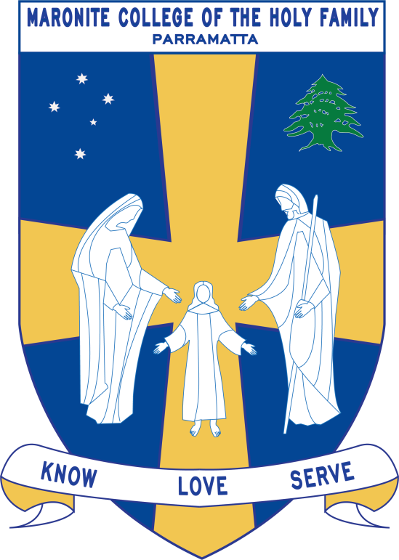

2017

Teaching Staff

Grade: Year 5

Grade Teachers : Mrs Hill and Mrs Guinan
Miss Francis
Mrs Sadek
Miss Loulach

Stage 3 Coordinator: Miss Azzi

EAL/D,Integration Teachers: Mrs Delia and
Ms Pamboukian
Miss Azzi
Ms Achmar

Arabic Teachers: Mrs Sassine
Mrs Zaiter
Mrs Chalhoub
Mrs Farah

Learning Centre Teacher: Miss Roumanus
Curriculum Notes

Homework:
Your Child should be spending 60 minutes on homework each night.

      - Spelling- children to revise their words each night.
      - Students will receive a worksheet to complete based on the topics being studied.
      - Reading - Your child should be reading every night for at least 25 minutes.
      - Revision and studying of class work.
      - Arabic homework
Perfect homework reward: These rewards will be negotiated with the students by the class teacher.

Key Learning Areas

KLA | Outcome Description | Unit Outline
English | EN3-1A - communicates effectively for a variety of audiences and purposes using increasingly challenging topics, ideas, issues and language forms and features.  EN3-2A – composes edits and presents well-structured and coherent texts.  EN3-3A - uses an integrated range of skills, strategies and knowledge to read, view and comprehend a wide range of texts in different media and technologies.  EN3-4A - draws on appropriate strategies to accurately spell familiar and unfamiliar words when composing texts.  EN3-5B - discusses how language is used to achieve a widening range of purposes for a widening range of audiences and contexts.  EN3-6B - uses knowledge of sentence structure, grammar, punctuation and vocabulary to respond to and compose clear and cohesive texts in different media and technologies.  EN3-7C - thinks imaginatively, creatively, interpretively and critically about information and ideas and identifies connections between texts when responding to and composing texts.  EN3-8D - identifies and considers how different viewpoints of their world, including aspects of culture, are represented in texts.  EN3-9E recognises, reflects on and assesses their strengths as a learner. | Speaking and Listening  Students will be expected to participate in a range of activities that focus on developing their skills and confidence in Talking and Listening.  The various activities will include role plays, class debates, class discussions, oral speeches and listening activities integrated with HSIE, Religion and Health. Students explain how answers are obtained in Mathematics.  Students are encouraged to listen attentively at all times.  Writing  Students will read, discuss, deconstruct and write Imaginative Texts (Poetry), focusing on sentence structure, paragraphing and punctuation.  Students will be expected to write an Informative Text (Information Report) about the Desert. This will also involve extensive research in the library, at school and at home. Students will be encouraged to use a range of research skills and resources including the internet.  Grammar and Punctuation:  Students will be improving and developing their grammar and punctuation skills weekly through explanation and discussion of grammar and punctuation rules.  The Grammar and Punctuation concepts taught this term include use of figurative language, investigating first, second and third person and use of heading, subheading and summarization.  Spelling:  Students will receive a new spelling list at the beginning of each week and will be tested on Thursday. Each student will have their own set quota. The Spelling words will be based on the Year 5 core spelling list as well as words which are related to topics the students are currently studying. They will move up a quota after achieving full marks over two consecutive weeks.  Shared Reading/Viewing  Shared Reading involves the students reading as a class and discussing the texts. Students respond to the texts by completing Shared Reading activities that focus on structure, grammar, punctuation and comprehension. The Shared Reading resources include Onion Tears by Dianne Kidd. Students will also be looking a t visual and multimodal resources about refugees.They will also look at informative texts through interactions with documentaries about the desert.  ICT  ICT skills will be integrated throughout teaching and learning programs. Students will have access to the Primary Lab as well as iPads and laptops in classrooms in order to meet their learning needs.  Reading Groups  Students will participate in reading groups three times a week for forty minutes. Reading books are based on the students individual reading levels and involve a range of comprehension activities based on the text. They are also expected to read at home every night.
Mathematics | Number and Algebra  MA3-1WM- describes and represents mathematical situations in a variety of ways using mathematical terminology and some conventions.  MA3-2WM- selects and applies appropriate problem-solving strategies, including the use of digital technologies, in undertaking investigations  MA3-8NA analyses and creates geometric and number patterns, constructs and completes number sentences, and locates points on the Cartesian plane.  Measurement  MA3-14MG Identifies three dimensional objects, including prisms and pyramids, on the basis of their properties, and visualises, sketches and constructs them given drawings of given views  MA3-11MG selects and uses the appropriate unit to estimate, measure and calculate volumes and capacities and convert between units of capacity.  Statistics and Probability  MA3-19SP conducts chance experiments and assigns probabilities as values between zero and one to describe the outcomes.  Please note – Working Mathematically outcomes are incorporated throughout all content in Mathematics | Students identify and describe factors and multiples of whole numbers and use them to solve problems. Students determine all ‘factors’ of a given whole number, eg 36 has factors 1,2,3,4,6,9,12,18 & 36. Students determine the ‘highest common factor’ (HCF) of 16 & 24 is 8. Students determine ‘multiples’ of a given whole number, eg multiples of 7 are 7, 14, 21, 28,….Students determine the ‘lowest common multiple’ (LCM) of two whole numbers, eg the LCM of 21 & 63 is 6.  Students will analyse and create geometric and number patterns and construct and complete number sentences.  Three-Dimensional Shape  Students classify 3D shapes and describe their features.  Volume and Capacity  Students select and use the appropriate unit to estimate, measure and calculate volumes and capacities and convert between units of capacity.  Chance  Students will conduct chance experiments and assigns probabilities as values between zero and one to describe the outcomes.  Working Mathematically  Problem Solving activities will be carried out throughout the week.
Religion  Studies in Religion are based on Christianity and in particular the Maronite faith. | CHURCH  demonstrate an understanding of the Church as a welcoming, caring and celebrating community which began its mission at Pentecost under the  inspiration and guidance of the Holy Spirit.  JESUS  demonstrate an understanding and appreciation of Jesus present in the sacramental life of the Church and who sends us the Holy Spirit to enliven and guide us.  SACRAMENTS  demonstrate an understanding and appreciation of the sacraments of Baptism, Confirmation and Eucharist where we celebrate our initiation into the Church, and of the sacraments of Penance and Anointing of the Sick as sacraments of God’s forgiveness and healing.  CHRISTIAN LIFE  demonstrate an understanding and appreciation of Christian life as living in accord with God’s commandments  PRAYER  demonstrate an understanding and appreciation of prayer as having many different forms, and as being intrinsic to the Mass and the celebration of the liturgical year.  The topics studied follow the Sharing Our Story document developed by the Catholic Education Office, Diocese of Parramatta.  The students will study the Feast Days and important times of the religious calendar, whilst also studying the Bible and its teachings | Christianity  - Introduce Christianity and explore different sectors of Christianity.  - Focus on Christian Sacraments such as Baptism, Penance, Eucharist, Confirmation, Holy Orders, Matrimony, and Anointing of the Sick.  Ecumenism  - Ecumenism - Christian unity  Feast Days  - Season of the Cross  - St Charbel’s and St Mary of The Cross Mackillop Feast day, The Assumption of Blessed Mary- 15th August  - Exaltation of the Cross – 14th September
Science | Biological Sciences – Micro-Organisms  ST3-11LW  Describes some physical conditions of the environment and how these affect the growth and survival of living things.  ST3-4WS  Investigates by posing questions, including testable questions, making predictions and gathering data to draw evidence-based conclusions and develop explanations.  ST3-5WT  Plans and implements a design process, selecting a range of tools, equipment, materials and techniques to produce solutions that address the design criteria and identified constraints.  ST3-4WS- Investigates by posing questions, including testable questions, making predictions and gathering data to draw evidence-based conclusions and develop explanations.  ST3-5WT- Plans and implements a design process, selecting a range of tools, equipment, materials and techniques to produce solutions that address the design criteria and identified constraints.  ST3-10LW- Describes how structural features and other adaptations of living things help them to survive in their environment. | Students will conduct open investigations to extend their conceptual understanding on micro- organisms by conducting experiments.  The students will take part in a variety of hands on experiences of the science phenomenon, in particular how plants and animals adapt to survive in the desert. They will explore ideas through experiments, collect evidence, discuss their evidence observations and keep records, such as science journals entries.
Personal Development, Health & Physical Education | Personal Development and Health  PHS3.12 explains the consequences of personal lifestyle choices  DMS3.2 makes informed decisions and accepts responsibility for consequences.  V4 increasingly accepts responsibility for personal and community health  Physical Education  GS83.8 Applies movement skills in games and sports that require communication, cooperation, decision making and observation of rules.  ALS3.6 Shows how to maintain and improve the quality of an active lifestyle.  V5 Willingly participates in regular physical activity. | Personal Health Choices  Students will look at some of the areas in which people make decisions including health decisions. The students will look at nutrition and will analyse their personal food intake. Students will also look at how the media influences body image and food intake and will look at health services and products.  Physical Education  Games and Sports – Soccer
Creative Arts | DRA S3.1 Develops a range of in-depth and sustained roles  DRA S3.2 Interprets and conveys dramatic meaning by using the elements of drama and a range of movement and voice skills in a variety of drama forms  DRA S3.3 Devises, acts and rehearses drama for performance to an audience  MUS3.2 Improvises, experiments, selects, combines and orders sound using musical concepts  MUS3.4 Identifies the use of musical concepts and symbols in a range of musical styles  VAS3.1 Investigates subject matter in an attempt to represent likenesses of things in the world  VAS3.2 Makes artworks for different audiences, assembling materials in a variety of ways  VAS3.4 Communicates about the ways in which subject matter is represented in artworks  DAS3.1 Performs and interprets dances from particular contexts using a wide range of movement skills and appropriate expressive qualities  DAS3.2 Explores, selects, organises and refines movement using the elements of dance to communicate intent | - Using their knowledge about nutritious food, students present a 1-minute commercial which aims to promote healthy choices. Students are to record their commercials using iPads or recording devices.  - Students listen to a variety of different environmental sounds (desert, rainforest, ocean etc.) then use musical instruments to create music relating to environmental sound. Students then listen to environmental music and sketch the scene. Students use paint, crayon, coloured pencils to add texture and shade.  - Students will sketch a sacrament symbol then use black oil pastels to colour their image. They will also use watered down paint to paint to the background, ensuring to blend the colours together.  - Students will create a dance with a focus on the dance elements of space, movement, time and dynamics.  - Students will create a drama skit piece, where they must remain in character throughout the performance.

