Maronite College of the Holy Family

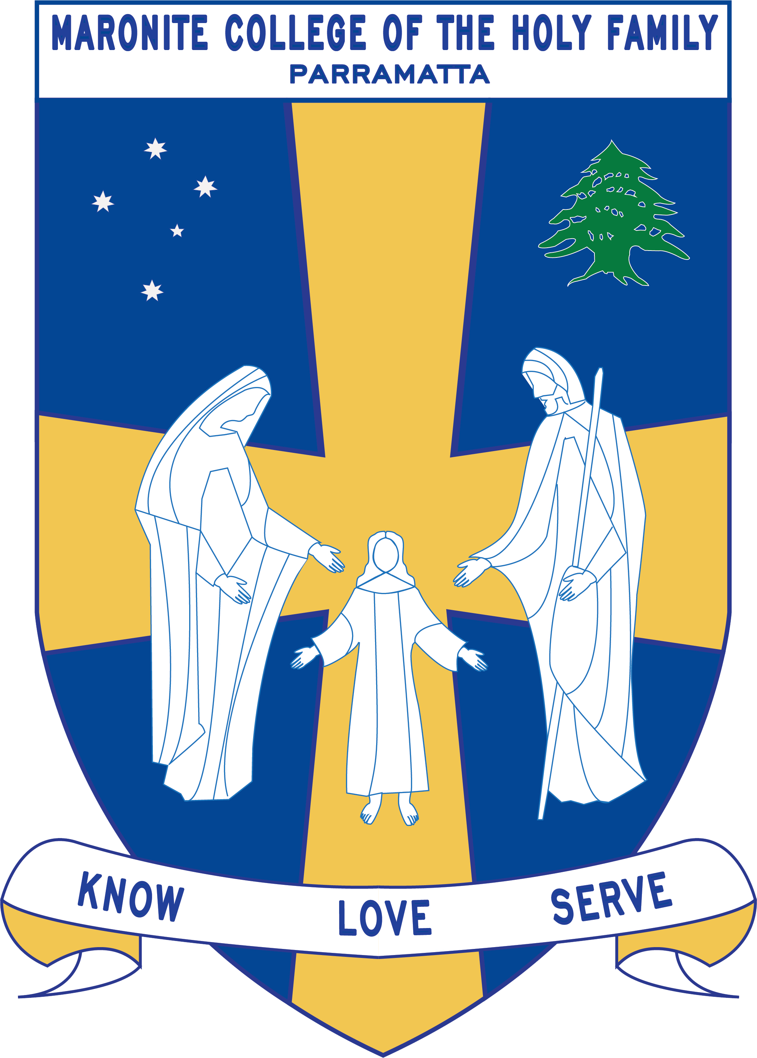

Grade Curriculum Notes: Kindergarten

2018

Teaching Staff

Grade: Kindergarten
Stage Coordinator Ms Rozario
Grade Teachers : Ms Khodeir
Ms Manolakos
Ms Alweddy
Ms Bechara

Arabic Teachers: Mrs Chalhoub
Mrs Farah
Mrs Zaiter
Mrs Sassine

Learning Centre Supervisor: Ms Roumanus

Integration/EAL/D Staff: Ms Rozario
Ms Le Merle
Ms Pantaleone
Ms Talarico

Curriculum Notes
Homework:

Each term the children will receive a homework grid focusing on English, Mathematics, Religion and Physical Education concepts. Students also receive a home reader and Magic Sight words that are to be completed every night. This goes home on the Monday and is to be returned on the Friday.

English/Mathematics:
Some of the key concepts covered in English and Mathematics include:

English

- Recites known nursery rhymes
- Use correct grammar when speaking to others
- Following directions and instructions
- Use knowledge of sounds (phonics) when reading and writing
- Reads irregular (tricky) words as a sight word list
- Understand what they have read
- Progress through leveled books at an individual rate
- Writes letters of the alphabet using the correct NSW Foundation Style letter formation
- Writes different types of texts (recount, information reports, descriptions, narratives)
- Uses capital letters, full stops and word spacing in the writing experience

Mathematics

- Counting, recognising and labelling groups of objects to 10
- Recognising number names to twenty
- Counting to 30; recognising numbers to 20; counting and labelling to 20
- Numbers before and after a given number; counting on from a given number
- The beginnings of addition (joining) and subtraction (taking away)
- The beginnings of multiplication (grouping) and division (sharing)
- Counting by two and five as a number pattern
- Creating and reading information from picture graphs
- Time: reading o’clock times on digital and analogue clocks, morning/night/afternoon, yesterday/today/tomorrow, days of the week, months of the year
- Shapes and shape names

Integrated Units: The following units are covered throughout the year:

 | Term 1 | Term 2 | Term 3 | Term 4
Religion | - Lent / Easter  - God Loves Me | My Family Loves Me | God Is Our Creator | - The Community That Celebrates God  - Christmas  - Jesus Is Born
Science and Technology/History/  Geography | Science:  Earth & Space Sciences: Weather in my World  Physical Sciences: On The Move | History:  Personal and Family Histories | Science:  Chemical Sciences: What’s it made of?  Biological Sciences: Staying Alive | Geography:  People live in places
Creative Arts | Creative Arts is integrated with thematic units
PDHPE | Physical Education Gymnastics  -Non-locomotor & Locomotor skills  - Elements of Movement and Composition.  Personal Development & Health  Personal Health Choices  - The students will be learning about the various ways in which they can make decisions which will influence their health in the areas of nutrition, health services and products, drug use, environmental health and preventative measures. | Physical Education Athletics and Active Lifestyle  This term the students will be focusing on Athletics (Games and Sports- Athletics) including the skills of running, jumping and throwing.  -They will also look at Ways to be Active through playing ball games and participating in obstacle courses.  Personal Development & Health  Safe Living  -Students will cover content on various Safety measures that need to be taken at school, home, rural, road, water, personal safety and will also learn about what to do in case of an Emergency.  Active Lifestyle- Components of an Active Lifestyle and the Effects of Physical Activity will also be taught this term. | Physical Education Minor Games  The students will actively participate in minor games including: miming/imitating, running, chasing, circle, simple ball games, cooperation games and parachute games.  Personal Development & Health  Interpersonal Relationships  - This term the students will learn about Relationships, Communication, Families, Peers and Groups. This will look at communicating feelings, developing positive relationships, working and playing with others. | Physical Education  Dance  The students will learn various dance styles, including folk, social, bush and creative. This will focus on developing appropriate non-locomotor and locomotor skills and will look at elements and compositions of various dances.  Personal Development & Health  Growth and Development  - This term the students will be learning about their Personal Identity, the different parts of the body including their senses and changes that occur from birth. They will also discuss Values, looking at likes, dislikes, acceptance of people’s uniqueness and differences.

Below are the allocated times for specialist classes:

 | Kinder White | Kinder Red | Kinder Blue | Kinder Rose
Learning Centre | Tuesday  (Borrowing Day Thursday) | Friday  (Borrowing Day Thursday) | Thursday  (Borrowing Day Thursday) | Monday  (Borrowing Day Thursday)
Arabic | Daily 11:20-11:50 | Daily 11:20-11:50 | Daily 11:20-11:50 | Daily 11:20-11:50
Sport | Wednesday | Wednesday | Wednesday | Wednesday

Kindergarten - Term 2 Overview 2018
This is a term overview for the teaching and learning for each subject in Kindergarten for Term 2.
KLA | Outcome Description | Unit Outline
English | Early Stage 1 outcomes  A student:  communicates with peers and known adults in informal and guided activities demonstrating emerging skills of group interaction  ENe-1A  composes simple texts to convey an idea or message  ENe-2A  produces most lower case and upper case letters and uses digital technologies to construct texts  ENe-3A  demonstrates developing skills and strategies to read, view and comprehend short, predictable texts on familiar topics in different media and technologies  ENe-4A  demonstrates developing skills in using letters, simple sound blends and some sight words to represent known words when spelling  ENe-5A  recognises that there are different kinds of spoken texts with specific language features and shows an emerging awareness of some purposes for spoken language  ENe-6B  recognises that there are different kinds of spoken texts with specific language features and shows an emerging awareness of some purposes for spoken language  ENe7B  recognises some different purposes for writing and that own texts differ in various ways  ENe-8B  demonstrates emerging skills and knowledge of texts to read and view, and shows developing awareness of purpose, audience and subject matter.  ENe-9B  demonstrates developing skills and knowledge in grammar, punctuation and vocabulary when responding to and composing texts  ENe-10C  thinks imaginatively and creatively about familiar topics, simple ideas and the basic features of texts when responding to and composing texts  ENe-11D  responds to and composes simple texts about familiar aspects of the world and their own experiences  ENe-12E  demonstrates awareness of how to reflect on aspects of their own and others’ learning | Speaking  Students will be presenting their news item once a week and they will be asked questions about their news by their peers. Student’s news presentation will be assessed throughout the term.  Listening  Students will be involved in various listening activities and will be assessed accordingly. For example, students will complete and make a scarecrow, a sheep and a giraffe by listening to a series of instructions.  Reading and Viewing  Reading groups will be held four times a week for 40 minutes. The students are also expected to read at home every night for a minimum of 10 minutes.  Every two weeks the Kindergarten children will read a shared text. The children will then complete related activities involving reading, comprehension, grammar and talking and listening.  Writing and Representing  Writing in Term 2 focuses on informative and persuasive text. In informative writing children will now be using time connectives to sequence the order of events. They will write about their holidays, the weekend, letters and descriptions using adjectives and nouns etc.  We focus on correct pencil grip and correct letter formation and using NSW Foundation Writing.  Library Borrowing-  - Caring for books: clean hands, book handling, keeping books safe  - Familiarisation with the CBCA 2013 Book of the Year: Early Childhood Notable Books  - Borrowing and returning
Mathematics | Number  Whole Numbers  MAe-4NA  Counts to 30, and orders, reads and represents numbers in the range 0 to 20  Addition and Subtraction  MAe-5NA  Combines, separates and compares collections of objects, describes using everyday language, and records using informal methods.  Fractions and Decimals  MAe-7NA  Describes two equal parts as halves.  Patterns and Algebra  MAe-8NA  Recognises, describes and continues repeating patterns.  Measurement and Geometry  MAe-9MG  Describes and compares lengths and distance using everyday languages.  Area  MAe-10MG  Describes and compares area using everyday languages.  Volume and Capacity  MAe-11MG  Describes and compares capacity of containers and the volumes of objects or substances using everyday languages  Time  MAe-13MG  Sequences events, uses everyday language to describe the durations of events, and reads hour time on clocks  Two-Dimensional Shapes  MAe-15MG  Manipulates, sorts and describes representations of two dimensional shapes, including circles, triangles, squares and rectangles, using everyday languages. | Students will:  - count forwards to 30.  - counts with one to one correspondence.  - write numbers to 30 using numerals.  - present numbers to 10 using dot patterns and objects.  - sequence numbers to 30.  - matches numeral and number words to 10.  - students are introduced to the use of a calculator and its features and look at different ways a numeral can be represented.  - students sequence and record events using ordinal numbers.  Students will continue to play CMIT games to reinforce counting, number recognition, sequencing and dot patterns  - Addition: Joins two groups of objects and states the total number.  - Subtraction: Takes part of a group of objects away and states the number of objects remaining.  - students share and divide objects into two equal parts.  - Students will create and continue 2 or 3 repeat patterns using everyday objects. Students will then create and draw 2 or 3 repeat patterns in their book or on their worksheet.  - Students can measure and compare the length of objects.  - Students measure an area using informal measurement.  - Students recognise and compare when a container is full, empty and about half full.  - Students compare the mass of two objects and can describe the mass using everyday language.  - Reads hours on an analogue and digital clock.  - Students sequence the events of the day.  - Students identify and create two dimensional shapes and can describe them using everyday language.
Religion | Studies in Religion is based on Christianity and in particular the Maronite faith. The students will study the Feast Days and important times of the religious calendar, whilst also studying the Bible and its teachings.  The focus is on families and how we can relate it to Jesus. The children will demonstrate an understanding and appreciation of their families and of the different families in our community.  The topics studied follow the Sharing Our Story document developed by the Catholic Education Office, Diocese of Parramatta. | The concepts we are looking at are;  - Our families and similarities and differences between families. Children will be creating a family tree.  - Children will be exploring the special events and occasions celebrated by families. For example, birthdays, weddings, christenings and anniversaries.  - Children will be making a prayer thanking God for making our families.  - Stories from the Bible will be read to the children as we relate to God’s family.
History | HTe- 1: communicates stories of their own family heritage and the heritage of others  HTe- 2: Demonstrates developing skills of historical inquiry and communication | - Who the people in their family are, where they were born and raised and how they are related to each other  - How the stories of families and the past can be communicated, for example through photographs, artefacts, books, oral histories, digital media and museums  - Students:  - Identify people in their immediate families and show relationships between family members  - Discuss where members of their families were born and locate countries of origin of students' families in the class  - Use a variety of sources including photographs or a treasured object from their homes, to recount stories about their families and discuss how sources are used to answer the question 'How do we know?'  - Discuss the significance of the chosen treasured object or photograph (it may be important or significant to themselves but not to others  - Pose questions about another's object or photograph  - Discuss then and now; past and present  - Identify and sequence stages in their lifetime  - Recognise that stories of the past may differ depending on who tells the story, eg stories of their childhood told by themselves and another member of the family  - The different structures of families and family groups today, and what they have in common  - Students:  - Identify and record similarities and differences between families, e.g. the number of children in the family, family languages spoken at home, number of adults in the immediate family  - Compare and contrast various family groups through photographs and stories and identify differences between past and present  - Engage in and respond to stories about families in other places, including those of Aboriginal and Torres Strait Islander groups  - How they, their family and friends commemorate past events that are important to them  - Students:  - Share experiences of family, school and local events that are celebrated or observed  Identify and record a variety of holidays and special events observed in Australia and other countries, e.g. birthdays, anniversaries and festivals. Consider the significance of these dates.
Personal Development, Health & Physical Education | INES1.3 Relates well to others in work and play situations.  COES1.1 Expresses feelings, needs and wants in appropriately in ways  PSES1.5 Seeks help as needed when faced with simple problems  SLES1.13 Demonstrates an emerging awareness of the concepts of safe and unsafe living  V4 increasingly accepts responsibility for personal and community health  Cross Curricular-  DRAES1.1 Uses imagination and the elements of drama in imaginative play and dramatic situations  ALES1.6 - develops a repertoire of physical activities in which they can participate  GSES1.8 – demonstrates fundamental movement skills while playing with and sharing equipment  MOES1.4 - demonstrates a general awareness students of how basic movement skills apply in play and other introductory movement experiences  V2- respects the right of others to hold different values and attitudes from their own  V3 - enjoys a sense of belonging.  V4 – Increasingly respects responsibility for personal and community health  V5 - willingly participates in regular physical activity | PERSONAL DEVELOPMENT AND HEALTH  Safe Living-Students will continue to cover content on various Safety measures that need to be taken at school, home, rural, road, water, personal safety and will also learn about what to do in case of an Emergency.  PE- Children will continue to develop a range of physical skills and games including catching and throwing, jumping and kicking skills and ball skills.  Children will also participate in a number of activities in order to prepare for the Athletics Carnival.
Creative Arts | Visual Arts:  Making  VAES1.1 Makes simple pictures and other kinds of artworks about things and experiences.  VAES1.2 Experiments with a range of media in selected forms.  Appreciating  VAES1.3 Recognises some of the qualities of different artworks and begins to realise that artists make artworks.  VAES1.4 Communicates their ideas about pictures and other kinds of artworks.  Drama  Making  DRAES1.1 Uses imagination and the elements of drama in imaginative play and dramatic situations.  Performing  DRAES1.3 Dramatises personal experiences using movement, space and objects.  Appreciating  DRAES1.4 Responds to dramatic experiences.  Dance  DAES1.1 Participates in dance activities and demonstrates an awareness of body parts, control over movement and expressive qualities.  DAES1.2 Explores movement in response to a stimulus to express ideas, feelings or moods.  DAES1.3 Responds to and communicates about the dances they view and/or experience. | This term, kindergarten will be exploring a range of visual art mediums. Students will focus on important celebrations and Mother’s Day. Students will explore various artists and the art forms.  Students will use their imagination and dramatic plays to retell a story using personal experiences.  Students will explore free body movement to various types of music. Students are encouraged to explore their action, dynamics, time, space, relationships and structure during lessons. Students will primarily focus on learning and choreographing dance steps.

