Maronite College of the Holy Family

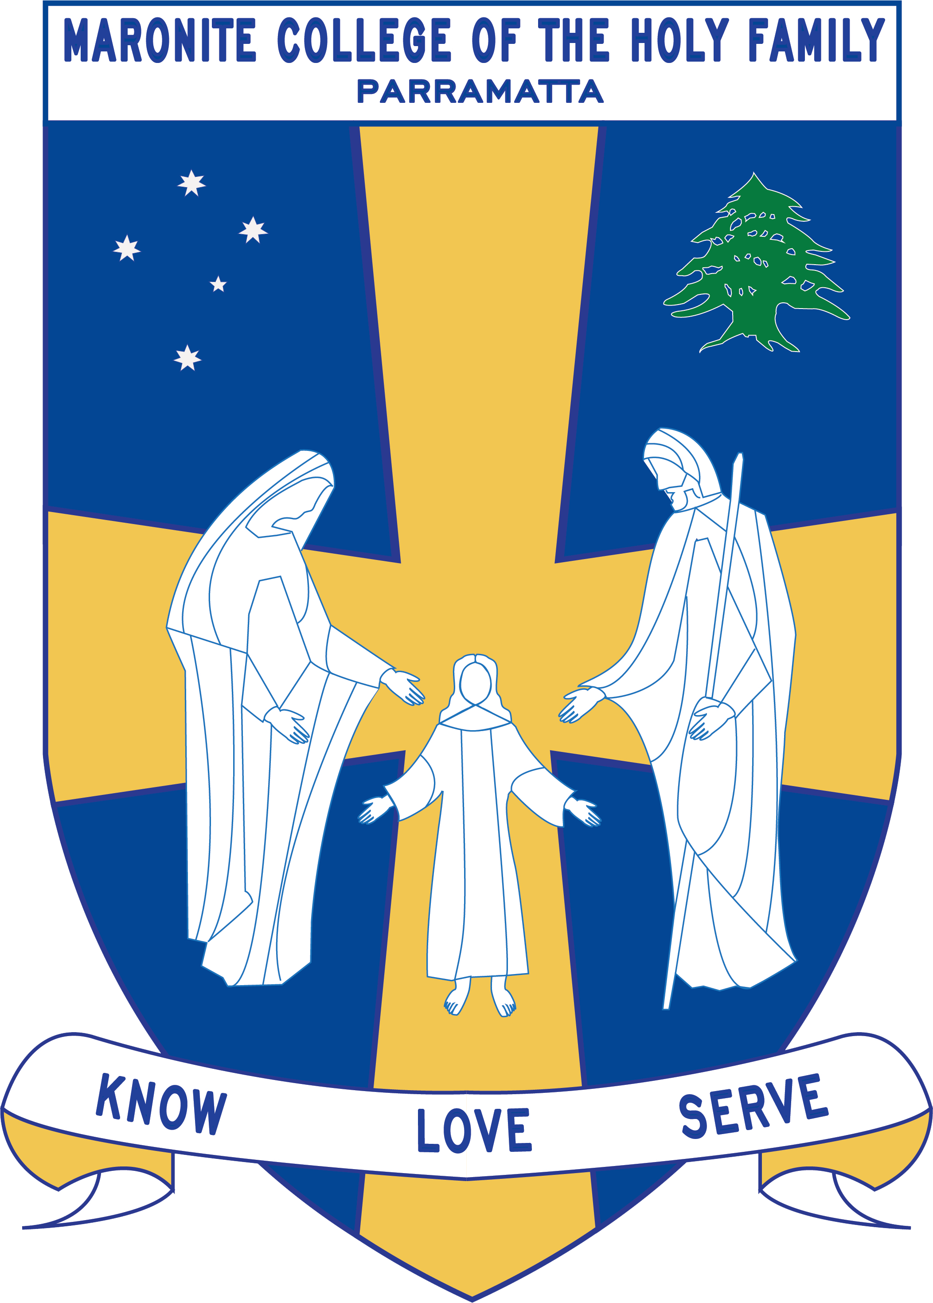

Term 2
Curriculum Notes: Learning Centre
Miss Roumanus

2018

Year | Outcomes | Overview
Kindergarten | HTe-1 communicates stories of their own family heritage and the heritage of others  HTe-2 demonstrates developing skills of historical inquiry and communication | History: Personal and family histories  Kindergarten will explore the different structures of families and family groups today, and what they have in common. They will also discuss how they, their family and friends commemorate past events that are important to them.
1 | HT1-1 communicates an understanding of change and continuity in family life using appropriate historical terms  HT1-4 demonstrates skills of historical inquiry and communication | History: Present and Past family life  Year one will explore the present, past and future plus days of the week, months and seasons. They will also identify dates of personal significance to them and those of other cultures.
2 | ST1-10LW describes external features, changes in and growth of living things  ST1-11LW describes ways that different places in the environment provide for the needs of living things  ST1-9ES identifies ways that people use science in their daily lives to care for the environment and the Earth’s resources | Science: Living world  Year 2 will construct a mini eco-system to observe and record the lifecycle of a plant. They will also participate in fieldwork around the school and local area recording observations and exploring the needs of the plants for survival.  Science: Earth and Space  Year 2 will explore Earth’s resources and their importance. They will construct a jam jar and water cycle to understand their importance in the environment
3 | ST2-12MW  identifies that adding or removing heat causes a change of state between solids and liquids  ST2-13MW  identifies the physical properties of natural and processed materials, and how these properties influence their use  ST2-4WS  investigates their questions and predictions by analysing collected data, suggesting explanations for their findings, and communicating and reflecting on the processes undertaken  ST2-5WT  applies a design process and uses a range of tools, equipment, materials and techniques to produce solutions that address specific design criteria  ST2-3VA  develops informed attitudes about the current and future use and influence of science and technology based on reason | Science: Material World  This unit will allow students to explore how the change of state between solids and liquids can be caused by adding or removing heat on different items. Students will be given the opportunity to make predictions and conduct hands-on experiments to enhance their scientific skills and knowledge.
4 | ST2-10LW describes that living things have life cycles, can be distinguished from non-living things and grouped, based on their observable features  ST2-11LW describes ways that science knowledge helps people understand the effect of their actions on the environment and on the survival of living things  ST2-5WT applies a design process and uses a range of tools, equipment, materials and techniques to produce solutions that address specific design criteria  ST2-2VA demonstrates a willingness to engage responsibly with local, national and global issues relevant to their lives, and to shaping sustainable futures  ST2-4WSinvestigates their questions and predictions by analysing collected data, suggesting explanations for their findings, and communicating and reflecting on the processes undertaken | Science: Living World  Year 4 will work collaboratively on a first-hand observation of the life cycle of a plant or animal. Students will also explore online presentation devices particularly Weebly.
5 | ST3-6PW describes how scientific understanding about the sources, transfer and transformation of electricity is related to making decisions about its use  ST3-7PW uses scientific knowledge about the transfer of light to solve problems that directly affect people’s lives  ST3-5WT plans and implements a design process, selecting a range of tools, equipment, materials and techniques to produce solutions that address the design criteria and identified constraints | Science: Physical World  In this learning unit, Year 5 students will engage in a variety of first-hand experiences which will increase their understanding of electrical energy (electricity). They will conduct investigations with simple materials such as wires, batteries and light bulbs to make simple circuits. Students will research and test insulators and conductors, and devised a switch that will turn a light bulb on and off.  Students will also be exploring the computer coding program called Scratch.
6 | ST3-8ES Describes how discoveries by people from different cultures and times have contributed to advancing scientific understanding of the solar system  ST3-9ES Explains rapid change at the Earth’s surface caused by natural events, using evidence provided by advances in technology and scientific understanding  ST3-5WT Plans and implements a design process, selecting a range of tools, equipment, materials and techniques to produce solutions that address the design criteria and identified constraints | Science: Earth and Space  Year 6 will explore the planets, it’s features and the planets history explaining how peoples from different cultures and time contributed to the understanding of the solar system.  Students will create a design brief to assist them to design and make a replica of a natural disaster in a part of the world demonstrating the rapid changes it has on the Earth’s surface.

