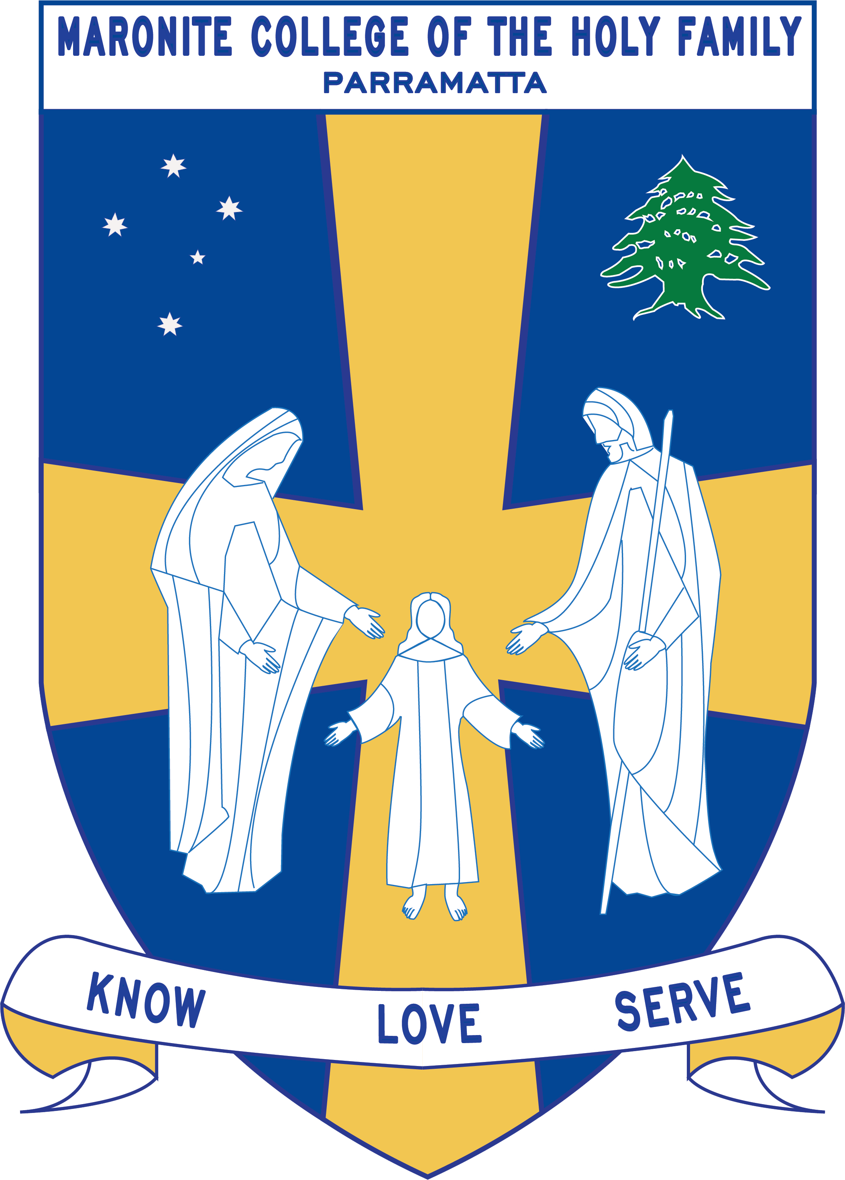
Maronite Sisters of the Holy Family
Maronite College of the Holy Family

23-25 Alice Street Harris Park NSW 2150; Tel (02) 9633 6600 Fax (02) 9689 1662
Email: admin@mchf.nsw.edu.au Web: www.mchf.nsw.edu.au
Maronite College of the Holy Family

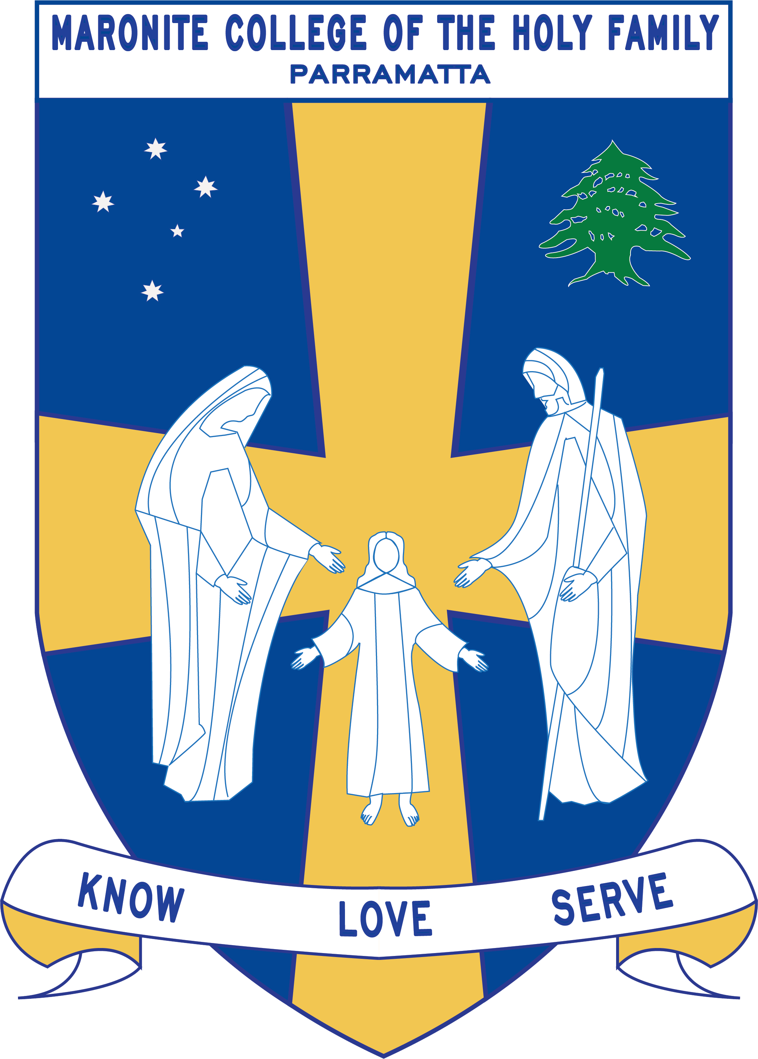

Grade Curriculum Notes: Year 4

2018
Teaching Staff

Grade: Year Four

Grade Teachers: Ms Dib
Mrs Ramsey
Ms Dimassi
Ms Nohra

Integration Teachers: Mrs Maxwell / Ms Pamboukian

Stage Coordinator Ms Mallia
EAL/D Teacher: Ms Mallia

Teacher Support: Mrs Achmar / Mrs Nemer

Arabic Teacher: Mrs Zaiter
Mrs Sassiner
Mrs Farah
Mrs Chalhoub

Learning Centre Supervisor: Ms Roumanus

Curriculum Notes
Homework:
Your Year 4 child should be spending 40 minutes on homework each night. Homework tasks will include the following each week.

- Spelling words
- English Literacy Choice Board
- Mathematics Literacy Choice Board
- English Activities
- Maths Activities
- Reading
Perfect homework reward:
Term 1: To be decided by class.
Term 2: To be decided by class.
Term 3: To be decided by class.
Term 4: To be decided by class.
NOTE: Students who have a 100% home completion rate will be rewarded within their classrooms.
English/Mathematics:

 | Term 1 | Term 2 | Term 3 | Term 4
English | The Key Learning Area of English is divided into Reading and Viewing, Writing and Representing, Speaking and Listening, Spelling, Responding and Composing,  Grammar, Punctuation and Vocabulary, Thinking Imaginatively, Creatively, Interpretatively and Critically, Expressing Themselves and Reflecting on Learning. It is envisaged that the Year 4 program will assist in the development of the student becoming more proficient in the four areas.  Reading and Viewing: Reading occurs in all Key Learning Areas. During the literacy blocks, skills, strategies and knowledge to read, view and comprehend a wide range of texts will be integrated with texts in different media and technologies. Students will be supported by Mrs Maxwell, Ms Pamboukian, Mrs Achmar/ Mrs Nemer during reading lessons.  Writing and Representing: Each week the students will participate in writing activities. Revision will take place, as well as improving the students’ knowledge of the types of texts. Grammar, structure and punctuation will be a key focus.  Handwriting: Students participate in handwriting each week using the ‘New Improved Foundation Handwriting’ text book. The students will practise the NSW foundation style of handwriting.  Spelling: Spelling is based on the quota spelling system with a maximum of 20 words. Students complete weekly activities and are tested each week on Thursday.  Speaking and Listening: Speaking and Listening activities are integrated across Key Learning Areas of the curriculum. Children are encouraged to listen to instructions, information from peers. This will include oral presentations.  Responding and Composing: Students develop an understanding and apply knowledge of language forms and features. Students also respond to and compose texts.  Grammar, Punctuation and Vocabulary: Students are given a variety of activities related to shared reading texts. It is also integrated into all other key learning areas.  Thinking Imaginatively, Creatively, Interpretatively and Critically: Students engage personally with the text, develop and apply contextual knowledge, understand and apply knowledge of language forms and features. They also respond to and compose texts.  Expressing Themselves: Students identify and consider how different viewpoints of their word, including aspects of culture, are represented in texts.  Reflecting on Learning: Students recognise, reflect on and assess their strengths as a learner.
Mathematics | Number and Algebra, Measurement and Geometry and Statistics and Probability are all covered throughout the year. Students will be assessed after each topic is covered.  Working Mathematically – This strand is integrated into the content of all areas of Mathematics.
Integrated Units:
 | Term 1 | Term 2 | Term 3 | Term 4
Religion | 1. Sacraments of Initiation  2. Practices and Promises  3. Passover: Exodus | - New Life  - Eucharist – Structure of the Mass | - Reconciliation: God’s forgiveness and healing.  - The Bible: A Special Book | 1. Mission: Serving Others with Jesus.  2. Be a Joyful Messenger
History/  Geography/  Science | First Contacts | Science –Living Things | Geography- The Earth’s Environment | Science – Earth and Space
 | The students attend a lesson in the computer room once a week for 60 minutes with their class teacher.
Creative Arts | Visual Arts  - Aboriginal Instruments  Drama  -Perform your own ending  Music  -Beat, Rhythm, Dynamics, Tone, Texture and Tempo | Dance  -Dance Around the World  Visual Arts  -Picasso & The Weeping Woman  Stone Art – Refugee Families Journey  Drama-Improvisation Freeze Frames | Visual Arts  -Perspective  Drama  -Charlie and the Chocolate Factory  Music  -Music Features and Notions | Dance  1.Dance maps and choreography  2. Visual Arts  Van Gogh  3. Drama
PDHPE  Sport day- Tuesday | PD/H Active Lifestyle  PE: Newcombe Ball  Swimming | PD/H Growth & Development  Safe Living  PE: Netball Skills | PD/H Personal Health Choices  PE: Dance | PD/H Growth and Development  Personal Health Choices  PE: AFL Skills & Field Hockey

Other:
 | 4 Olive | 4 Aqua | 4 Amber | 4 Violet
Learning Centre | Thursday  11:00 – 12:00  Borrowing  Wednesday  12:15 | Friday  1:30-2:30  Borrowing  Wednesday  9:00 | Friday  1:30 – 2:30  Borrowing  Tuesday  9:00 | Thursday  11:00-12:00  Borrowing  Thursday  12:00
Arabic | Monday – Friday 2:30 – 3:00

Year 4 - Term 4 Overview 2018
This is a term overview for the teaching and learning for each subject in Year 4 for Term 3.
Please make an appointment to speak to your child’s teacher if you have any questions.
KLA | Outcome Description | Unit Outline
English | Speaking and Listening  EN21-A communicates in a range of informal and formal contexts by adopting a range of roles in group, classroom, school and community contexts.  EN2-6B Identifies the effect of purpose and audience on spoken texts, distinguishes between different forms of English and identifies organisational patterns and features.  Reading and Viewing  EN2-4A Uses an increasing range of skills, strategies and knowledge to fluently read, view and comprehends a range of texts on increasingly challenging topics in different media and technologies.  EN2-8B Identifies and compares different types of texts when reading and viewing and shows an understanding of purpose, audience and subject matter.  Writing and Representing  EN2-2A Plans, composes and reviews a range of texts that are more demanding in terms of topic, audience and language.  EN2-6B Identifies the effect of purpose and audience on spoken texts, distinguishes between different forms of English and identifies organizational patterns and features  EN2-7B Identifies and uses language forms and features in their own writing appropriate to a range of purposes, audiences and contexts.  EN2-8B Identifies and compares different kinds of text when reading and viewing and shows an understanding of purpose, audience and subject matter  EN2-9B Uses effective and accurate sentence structure, grammatical features, punctuation conventions and vocabulary relevant to the type of text when responding to and composing texts  EN2-10C Thinks imaginatively, creatively and interpretatively about information, ideas and texts when responding to and composing texts  Spelling  EN2-5A Uses a range of strategies, including knowledge of letter–sound correspondences and common letter patterns, to spell familiar and some unfamiliar words.  Grammar, Punctuation and Vocabulary  EN2-9B Uses effective and accurate sentence structure, grammatical features, punctuation conventions and vocabulary relevant to the type of text when responding to and composing texts.  Thinking Imaginatively, Creatively and Interpretively  EN2-10C Thinks imaginatively, creatively and interpretively about information, ideas and texts when responding to and composing text.  Handwriting and Using Digital Technologies  EN2-3A Uses effective handwriting and publishes texts using digital technologies.  Expressing Themselves  EN2-11D Responds to and composes a range of texts that express viewpoints of the world similar to and different from their own.  Reflecting on Learning  EN2-12E Recognizes and uses an increasing range of strategies to reflect on their own and others’ learning. | Speaking and Listening  Children will participate in a range of activities where they are required to speak and listen in group, paired and independent situations. They will present a speech/poem to their peers and learn about the effective use of voice, tone, eye contact and body language during their presentations.  Reading and Viewing  Students will have reading groups four times a week for thirty minutes. They are also expected to read at home every night for 20 minutes.  Students will be exposed to a variety of texts, including picture books ‘The Fearsome Frightening Ferocious Box’, ‘I want to be in a Book’, ‘Took the Children Away’ as well as a range of poems. Students will work with these texts to further develop their literal and inferential comprehension skills whilst integrating and linking ideas and asking questions to clarify understanding.  Writing and Representing  Throughout the term, students will be learning to compose imaginative and persuasive text through the use of picture books. The children will be asked to complete different types of persuasive and imaginative texts and will be assessed on their ability to draw on the language features and structure associated with the texts they have explored throughout the unit. The children will be involved in many meaningful discussions about the visual features used within the text and relate some of the events to their own life experiences and emotions.  Students will also be exposed to various forms of poetry through picture books, multimodal texts and print. They will learn how to analyse poems to interpret their meaning. Students will look closely at the structure, grammatical features and language associated with poems and apply this knowledge to construct their own.  Spelling Children will receive a new spelling list at the start of each week and will be tested on Thursday. Each student will have their own set quota. Students will move up a quota after achieving full marks over two consecutive weeks.  Throughout the term, students explore the structural, grammatical features and purposes for a range of imaginative and persuasive texts including poetry and explore their purpose, audience and structure.  Students participate in a weekly Handwriting lesson to teach them proper letter formation using NSW Foundation Style Handwriting. Students are encouraged to use cursive handwriting and are working towards getting their pen license. When they have mastered cursive handwriting, they will be given their pen license.
Mathematics | Number and Algebra: Addition & Subtraction  - MA2-5NA Uses mental and written strategies for addition and subtraction involving two, three, four, and five digit numbers  Measurement and Geometry: Three-Dimensional Space  - MA2-14MG Makes, compares, sketches and names three dimensional objects including prisms, pyramids, cylinders, cones and spheres and describes their features  Measurement and Geometry: Angles  - MA2-16MG Identify, describes, compares and classifies angles  Measurement and Geometry: Volume and Capacity  - MA2-11MG measures, records, compares and estimates volumes and capacities using litres, millilitres and cubic centimetres.  Number and Algebra: Patterns & Algebra  - MA2-8NA Generalises properties of odd and even numbers, generates number patterns, and completes simple numbers patterns by calculating missing values | Number and Algebra: Addition & Subtraction  -Money problems  -Calculate change  -Round to the nearest five cents  -Estimate solutions to addition and subtraction problems  Measurement and Geometry: Three-Dimensional Space  -Identify prisms in the environment  -Investigate types of three-dimensional objects in commercial packaging  -Sketching prisms  -Sketching 3D objects from different views  -Construction 3D objects  Measurement and Geometry: Angles  -Compare and classify angles  -Use an angle tester  -Create and draw angles  Measurement and Geometry: Volume & Capacity  -Litres and Millilitres  -Compare and order capacities  - Submerging objects to compare volume  Number and Algebra: Patterns & Algebra  -Finding the next term in a pattern  -Describing the position of the term  -Investigate visual number patterns
Religion | - The topics studied follow the Sharing Our Story document developed by the Catholic Education Office, Diocese of Parramatta.  - 24E- Mission: Serving others with Jesus  - 24C – Be A Joyful Messenger | Mission: Serving others with Jesus  Students will be developing a deeper understanding of the term Service and explore how Jesus served others. They will look at various Christian organisations that serve others in the same way that Jesus served. Students will begin their Christmas journey learning about the Annunciation of Mary. They will also develop a greater understanding of Christmas and how people celebrate Christmas around the world.  Be A Joyful Messenger  Students will be exploring the role and message of John the Baptist preparing for the coming our Lord.
Human Society & Its Environment / Geography | ST2-4WS investigates their questions and predictions by analysing collected data, suggesting explanations for their findings, and communicating and reflecting on the processes undertaken  ST2-5WT applies a design process and uses a range of tools, equipment, materials and techniques to produce solutions that address specific design criteria  ST2-8ES describes some observable changes over time on the Earth’s surface that result from natural processes and human activity  ST2-9ES describes how relationships between the sun and the Earth cause regular changes  EN2-7B identifies and uses language forms and features in their own writing appropriate to a range of purposes, audiences and contexts  EN2-9B uses effective and accurate sentence structure, grammatical features, punctuation conventions and vocabulary relevant to the type of text when responding to and composing texts | Earth and Space  Students explore geological processes and how these change the Earth’s surface over time. Students investigate types of rock and the effects of weathering and erosion.  Students investigate how weathering, erosion and human activity have affected local environments in Australia. Students apply their knowledge and understanding in a research project of a local landform, examining how weathering, erosion and human activity have affected their chosen landform over time and present their findings.
Personal Development, Health & Physical Education | GDS2.9 describes life changes and associated feelings  INS2.3 makes positive contributions in group activities  PHS2.12 discusses the factors influencing personal health choices  DMS2.2 makes decisions as an individual and group member  DAS2.7 performs familiar movement patterns in a variety of dance situations  INS2.3 makes positive contributions in group activities | Growth & Development  Students will be investigating the body including the following:  - Systems/ Functions  - Appropriate and Inappropriate Touch  - Rates of Stages of Growth and Development  - Heredity  Students will be investigating changes including the following:  - Physical Body Changes (including feelings about change)  - Changing Friendships and Relationships  Personal Health Choices: Nutrition  Students will be learning the following:  - Special Needs: Illness  - Special Needs: Culture  - Fast Food: A Health Choice  Physical Education: AFL Skills & Field Hockey  Students will be learning the skills required to play modifies games and ball games based on AFL Skills. They will engage in the skills of kicking, marking and hand balling.  In field hockey, students will engage in the skills of dribbling, passing and stealing when playing the game.
Creative Arts | VAS2.1 Represents the qualities of experiences and things that are interesting or beautiful by choosing among aspects of subject matter.  VAS2.3 Acknowledges that artists make artworks for different reasons and that various interpretations are possible.  DAS2.1 Performs dances from a range of contexts, demonstrating movement skills, expressive qualities and an understanding of the elements of dance.  DAS2.2 Explores, selects and combines movement using the elements of dance to communicate ideas, feelings or moods.  DRAS2.1 Takes on and sustains roles in a variety of drama forms to express meaning in a wide range of imagined situations  DRAS2.2 Builds the action of drama by using the elements of drama, movement and voice skills. | Visual Arts  Students will be studying ‘The Starry Night” by Vincent Van Gogh and will experiment with different art techniques to create their own Van Gogh inspired piece.  They will also be making representations of snowflakes and Christmas trees using paper folding and cutting techniques.  Dance  Students will be studying Dance Maps and creating their own dance map using the language of dance to explain and demonstrate movement.  Drama  Students will be completing a drama role-play based on the Christmas Story.

