Maronite College of the Holy Family

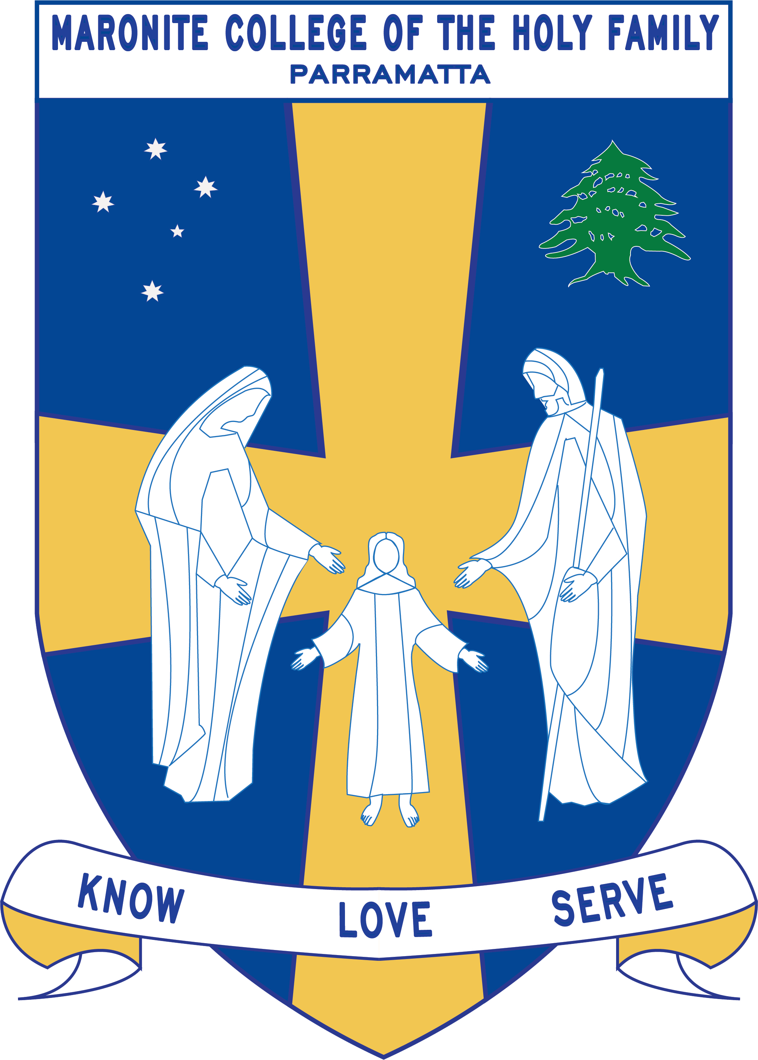

Grade Curriculum Notes: Kindergarten

2019

Teaching Staff

Grade: Kindergarten

Stage Coordinator: Mrs Vrontas
Special Needs Coordinator: Mr Perret
Grade Teachers : Ms Bechara
Ms Alweddy
Ms Delos Reyes
Ms Hanna

Arabic Teachers: Mrs Chalhoub
Mrs Farah
Mrs Zaiter
Mrs Sassine

Learning Centre Supervisor: Ms Le Merle/ Ms Hort

Integration/EAL Staff: Ms Pantelone
Ms Maxwell

Learning Support: Katie Zdrilic

Curriculum Notes
Homework:
Your child should be spending 10 – 15 minutes on homework each night.

Each term the student will receive a homework grid focusing on English, Mathematics, Religion and Physical Education concepts. Students also receive a home reader and Magic Sight words that are to be completed every night. This goes home on the Monday and is to be returned on the Friday. Homework starts in Week 3

English/Mathematics:
Some of the key concepts covered in English and Mathematics include:

English

- Recites known nursery rhymes
- Use correct grammar when speaking to others
- Following directions and instructions
- Use knowledge of sounds (phonics) when reading and writing
- Reads irregular (tricky) words on a sight word list
- Understand what they have read
- Progress through leveled books at an individual rate
- Writes letters of the alphabet using the correct NSW Foundation Style letter formation
- Writes different types of texts (Factual, Informative and Imaginative)
- Uses capital letters, full stops and word spacing in the writing experience

Mathematics

- Counting, recognising and labelling groups of objects to 10
- Recognising number names to twenty
- Counting to 30, recognising numbers to 20, counting and labelling to 20
- Numbers before and after a given number; counting on from a given number
- The beginnings of addition (joining) and subtraction (taking away)
- The beginnings of multiplication (grouping) and division (sharing)
- Counting by two and five as a number pattern
- Creating and reading information from picture graphs
- Time: reading o’clock times on digital and analogue clocks, morning/night/afternoon, yesterday/today/tomorrow, days of the week, months of the year
- Shapes and shape names

Count Me In Too (CMIT) activities, which focus on teaching Numeration to the students, are completed in each of the classrooms daily.

Integrated Units: The following units are covered throughout the year:

 | Term 1 | Term 2 | Term 3 | Term 4
Religion | - Lent / Easter  - God Loves Me | My Family Loves Me | God Is Our Creator | - The Community That Celebrates God  - Christmas  - Jesus Is Born
Science and Technology/History/  Geography | Science:  Physical Sciences: On The Move  Earth & Space Sciences: Weather in my World | History:  Personal and Family Histories | Science:  Chemical Sciences: What’s it made of?  Biological Sciences: Staying Alive | Geography:  People live in places
Creative Arts | Creative Arts is integrated with thematic units
PDHPE | Physical Education Gymnastics  -Non-locomotor & Locomotor skills  - Elements of Movement and Composition.  Personal Development & Health  Safe Living  -Students will cover content on various Safety measures that need to be taken at school, home, rural, road, water, personal safety and will also learn about what to do in case of an Emergency. | Physical Education Athletics and Active Lifestyle  This term the students will be focusing on Athletics (Games and Sports- Athletics) including the skills of running, jumping and throwing.  -They will also look at Ways to be Active through playing ball games and participating in obstacle courses.  Personal Development & Health  Personal Health Choices  - The students will be learning about the various ways in which they can make decisions which will influence their health in the areas of nutrition, health services and products, drug use, environmental health and preventative measures.  Active Lifestyle- Components of an Active Lifestyle and the Effects of Physical Activity will also be taught this term. | Physical Education Minor Games  The students will actively participate in minor games including: miming/imitating, running, chasing, circle, simple ball games, cooperation games and parachute games.  Personal Development & Health  Interpersonal Relationships  - This term the students will learn about Relationships, Communication, Families, Peers and Groups. This will look at communicating feelings, developing positive relationships, working and playing with others. | Physical Education  Dance  The students will learn various dance styles, including folk, social, bush and creative. This will focus on developing appropriate non-locomotor and locomotor skills and will look at elements and compositions of various dances.  Personal Development & Health  Growth and Development  - This term the students will be learning about their Personal Identity, the different parts of the body including their senses and changes that occur from birth. They will also discuss Values, looking at likes, dislikes, acceptance of people’s uniqueness and differences.

Below are the allocated times for specialist classes:

 | Kinder White | Kinder Red | Kinder Blue | Kinder Rose
Learning Centre | Tuesday  (Borrowing Day Thursday) | Tuesday  (Borrowing Day Thursday) | Wednesday  (Borrowing Day Thursday) | Monday  (Borrowing Day Thursday)
Arabic | Daily 11:20-11:50 | Daily 11:20-11:50 | Daily 11:20-11:50 | Daily 11:20-11:50
Sport | Wednesday | Wednesday | Wednesday | Wednesday
ICT | Monday | Tuesday | Thursday | Wednesday

Term 1 Overview
Below is a term overview for the work carried out for each subject in Kindergarten. You will also receive a similar outline at the beginning of terms 2, 3 and 4.
KLA | Outcome Description | Unit Outline
English | Early Stage 1 Outcomes  A student:  communicates with peers and known adults in informal and guided activities demonstrating emerging skills of group interaction  ENe-1A  composes simple texts to convey an idea or message  ENe-2A  produces most lower case and upper case letters and uses digital technologies to construct texts  ENe-3A  demonstrates developing skills and strategies to read, view and comprehend short, predictable texts on familiar topics in different media and technologies  ENe-4A  demonstrates developing skills in using letters, simple sound blends and some sight words to represent known words when spelling  ENe-5A  recognises that there are different kinds of spoken texts with specific language features and shows an emerging awareness of some purposes for spoken language  ENe-6B  recognises some different purposes for writing and that own texts differ in various ways  ENe-7B  demonstrates emerging skills and knowledge of texts to read and view, and shows developing awareness of purpose, audience and subject matter  ENe-8B  demonstrates developing skills and knowledge in grammar, punctuation and vocabulary when responding to and composing texts  ENe-9B  thinks imaginatively and creatively about familiar topics, simple ideas and the basic features of texts when responding to and composing texts  ENe-10C  responds to and composes simple texts about familiar aspects of the world and their own experiences  ENe-11D  demonstrates awareness of how to reflect on aspects of their own and others’ learning  ENe-12E  reflect on own reading and discuss the pleasure and challenges of learning to read | Speaking and Listening  Students will be presenting their news item once a week and they will be asked questions about their news by their peers. Student’s news presentation will be assessed throughout the term.  Students will be involved in various listening activities and will be assessed accordingly. For example, students will construct a sheep or a rabbit by listening to a series of instructions.  Reading and Viewing  Every two weeks the Kindergarten students will read a shared reading (modelled reading) text. The students will then complete related activities involving reading, comprehension, grammar and speaking and listening.  During Modelled Reading, the teacher models correct reading behaviours and exposes students to the skills and strategies that are vital to develop awareness of purpose, audience and subject matter.  Students will:  -build book and print awareness in students by modelling reading behaviours, such as reading from top to bottom and left to right  -build phonics skills in students by providing instruction and repeated practice in decoding books on their independent level  Texts:  - I like Myself by Karen Beaumont  -What would we do without Missus Mac? By Gus Clarke  - Big Earth, Little Me by Thom Whiley  - Look see, look at me! by Leone Norrington and Dee Huxley  - I went walking by Sue Machin  Reading groups will be held four times a week for 40 minutes. The students are also expected to read at home every night for 5 to 10 minutes.  Students explore,  - Caring for books: clean hands, book handling, keeping books safe  - Familiarisation with the Junior Fiction section  Borrowing and returning  Writing and Representing  Writing in Term 1 focuses on Imaginative and Informative texts. Children will begin their writing experience with “magic writing” and will progress into formal writing using NSW Foundation Writing.
Mathematics | Number and Algebra -Whole Number  MAe-4NA Counts to 30, and orders, reads and represents numbers in the range 0 to 20  Number and Algebra-Patterns & Algebra  MAe-8NA Recognises, describes, creates and continues repeating patterns  Statistics and Probability  MAe-17SP Represents and interprets data displays made from objects.  Measurement and Geometry- Length  MAe-9MG Describes and compares length and distance using everyday language.  Measurement and Geometry - Area  MAe-10MG Describes and compares area using everyday language.  Measurement and Geometry - Time  MAe-13MG Sequences events and uses everyday language to describe the duration of events, and reads hour time on clock.  Measurement and Geometry- Position  MAe-14MG Manipulates, sorts and represents three dimensional objects and describes them using everyday language. | -Students will:  - count forwards to 30.  - counts with one to one correspondence.  - write numbers to 10 using numerals.  - present numbers to 10 using dot patterns and objects  - sequence numbers to 10.  -Students will be divided into Count Me In Too Groups and will play CMIT games to reinforce counting, number recognition, sequencing and dot patterns.  -Students will create and continue 2 or 3 repeat patterns using everyday objects. Students will then create and draw 2 or 3 repeat-patterns in their book or on their worksheet.  -Students represent data informally using picture graphs. Students create a column graph based on the number of people in their family.  -Students use streamers to measure their height and make direct comparisons.  -Students measure the area of an object using smaller objects.  -Students will:  - identify when certain activities take place.  - recognize and sequence the days of the week.  -Students describe where specific objects are using everyday language, i.e. under, between, beside etc.
Religion  Studies in Religion are based on Christianity and in particular the Maronite faith. The students will study the Feast Days and important times of the religious calendar, whilst also studying the Bible and its teachings. | (1KC2) 01 * Lent / Easter  (1KC2) 01 * God Loves Me  The topics studied follow the Sharing Our Story document developed by the Catholic Education Office, Diocese of Parramatta | - Students prepare for Lent and learn about the story of Easter.  - Students discuss how much God loves us and how we can be more like God.
Science and Technology | Science  Physical World  - STe-1WS-S observes, questions and collects data to communicate ideas  - STe-2DP-T develops solutions to an identified need  - STe-5PW-ST observes the way objects move and relates changes in motion to push and pull forces  Earth and Space  -STe-1WS-S observes, questions and collects data to communicate ideas  -STe-6ES-S identifies how daily and seasonal changes in the environment affect humans and other living things  Digital Technologies  STe-2DP-T develops solutions to an identified need  STe-7DI-T identifies digital systems and explores how instructions are used to control digital devices | Science  The Physical World strand focuses on the physical characteristics of objects and the effects of these on how they move. This Early Stage 1 strand allows  students to investigate how push and pull forces create movement and introduces the fundamental concepts of force and motion.  The Earth and Space strand focuses on daily and seasonal changes in the environment. Students investigate how living things respond to these changes in the environment. Early Stage 1 of this strand introduces students to the foundational understanding of the Earth as a dynamic interrelated part of physical and biological systems.  Digital Technologies  Early Stage 1 of the Digital Technologies strand focuses on digital systems and how they are used to communicate. Students explore how algorithms can be used to solve problems. Early Stage 1 of this strand introduces students to computational thinking.  In this unit, students are introduced to digital technologies through a series of guided investigations using the technology available in classroom, school and home environments.  Students develop their use of correct terminology to clearly and precisely communicate instructions necessary when engaging with digital technology. Students use design activities to develop sequencing skills, enabling the achievement of larger tasks by breaking them into smaller, carefully ordered steps. In turn, they participate in following steps each has created to achieve a goal. When activities suggest the use of a device, an ‘unplugged’ option has been included for alternative delivery.
Personal Development, Health & Physical Education | Personal Development and Health  INES1.3 – Relates well to others in work and play situations.  COES1.1- expresses feelings, needs and wants in appropriate ways.  PSES15 - seeks help as needed when faced with different problems.  SLES1.13 - demonstrates an emerging awareness of the concepts of safe and unsafe living.  V4 - increasingly accepts responsibilty for personal and community health.  PHES1.12 - Displays basic positive health practices.  Cross-curricular-  DRAES1.3 dramatises personal experiences using movement, space and objects  Physical Education  GYES1.10 Performs basic movement patterns to show actions of the whole body  V3- enjoys a sense of belonging  V4 - willingly participates in regular physical activity  V5 – commits for realizing their full potential | Personal Development and Health  Children also consider safe rules for the classroom and the playground, healthy and unhealthy foods and health and hygiene i.e. showering and importance of brushing teeth.  Physical Education  Gymnastics- This term the students will focus on developing Non-locomotor, Locomotor skills, Elements of Movement and Composition.
Creative Arts | Music  Performing  MUES1.1 Participates in simple speech, singing, playing and moving activities, demonstrating an awareness of musical concepts.  Organising Sound  MUES1.2 Creates own rhymes, games, songs and simple compositions.  Listening  MUES1.4 Listens to and responds to music.  Visual Arts  Making  VAES1.1 Makes simple pictures and other kinds of artworks about things and experiences.  VAES1.2 Experiments with a range of media in selected forms.  Appreciating  VAES1.3 Recognises some of the qualities of different artworks and begins to realise that artists make artworks.  VAES1.4 Communicates their ideas about pictures and other kinds of artworks.  Drama  Making  DRAES1.1 Uses imagination and the elements of drama in imaginative play and dramatic situations.  Performing  DRAES1.3 Dramatises personal experiences using movement, space and objects.  Appreciating  DRAES1.4 Responds to dramatic experiences. | In Music, students are being introduced to the basic elements of Music with a particular emphasis on the beat. They have clapped, walked, marched, sang and played instruments to the beat while they are learning fun songs and games.  In Visual Arts, students depict different art mediums through techniques such as using sponges, paint, weaving, crayons and drawing.  In Drama, students will partake in dramatizing simple and well known nursery rhymes.

