Maronite College of the Holy Family

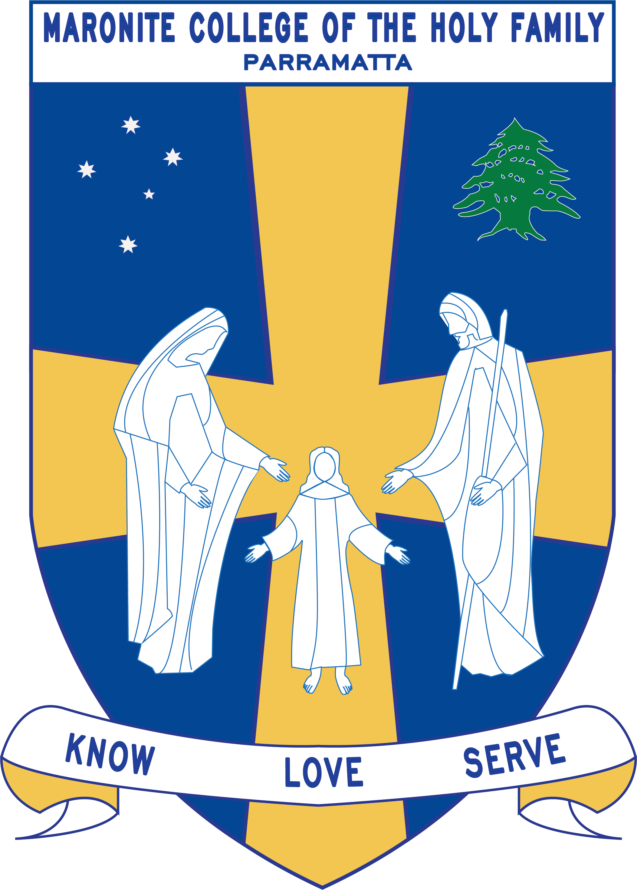

Grade Curriculum Notes: Year 6

2019

Teaching Staff
Grade Teachers | Ms Mourched  Ms. Mourani  Mrs. Murphy  Mrs. Guinan  Ms Azzi  Mr. Bechara
Stage 3 Coordinator | Ms. Mallia
EAL/D, Integration Staff: | Ms. Mallia  Ms Talarico
Arabic Teachers | Mrs. Sassine  Mrs. Zaiter  Mrs. Farah  Mrs. Chalhoub
Learning Centre Supervisor | Mrs Le Merle  Ms Hort
Learning Support Staff | Ms. Talarico  Mrs. Achmar

Curriculum Notes
Homework:

Your Year 6 child should be spending a minimum of 60 minutes on homework each school night. The following table outlines the set homework for Term 1 and all students are expected to complete all the set homework tasks each week.
Students will also record homework tasks in their college diary which must be brought to school with them each day and signed by a parent/guardian at the end of each week.
Homework is accessible via the school intranet using Moodle https://learn.mchf.nsw.edu.au/login/index.php

MONDAY
ENGLISH | - Look, Cover, Write, Check your spelling words and Synonyms.  - Spelling activity  - READ a book for enjoyment
MATHS | - Maths revision worksheet based on weekly topic studied in class
ARABIC | - Arabic homework set by class teacher

TUESDAY
ENGLISH | - Look, Cover, Write, Check your spelling words  - Comprehension activity  - READ a book for enjoyment
MATHS | - Maths revision worksheet based on weekly topic studied in class
ARABIC | - Arabic homework set by class teacher

WEDNESDAY
ENGLISH | 1. Look, Cover, Write, Check your spelling words.  2. Grammar activity  3. READ a book for enjoyment
MATHS | 4. Maths revision worksheet based on weekly topic studied in class
ARABIC | - Arabic homework set by class teacher

THURSDAY
ENGLISH | 1. Look, Cover, Write, Check your spelling words.  2. Writing/Viewing activity  3. READ a book for enjoyment
MATHS | 4. Maths revision worksheet based on weekly topic studied in class
ARABIC | - Arabic homework set by class teacher

English/Mathematics:

 | Term 1
English | The study of English is divided into several areas:  *Speaking and Listening *Writing and Representing  *Reading and Viewing *Spelling  *Responding and Composing * Grammar, Punctuation and Vocabulary  *Expressing Themselves *Reflecting on Learning  *Thinking Imaginatively, Creatively, Interpretively and Critically  The year 6 program is designed to help develop the student’s proficiency in all areas of the curriculum.  Reading and Viewing: Reading takes place throughout all Key Learning Areas, however skills and strategies will be taught during timetabled reading times using Guided Reading, Reader’s Circle and Independent Reading Strategies. The students will be exposed to a wide range of reading materials and whenever possible these will be linked to the other areas of English. Students will be engaged in more critical thinking tasks. They will be Responding to and Composing various works to demonstrate their understanding of a variety of texts.  Writing and Representing: The students will participate in a number of Writing activities each week, when they will revise and build upon their knowledge of the various types of texts. Particular emphasis will be placed on Grammar, Punctuation and Vocabulary elements of a text, as well as adding extra details which are relevant to Stage 3.  Speaking and Listening: The students will participate in regular activities designed to improve their Speaking and Listening skills and strategies. Speaking and Listening activities are also integrated across all areas of the school curriculum.  Spelling: Spelling activities are completed each week based on the Quota Spelling format. These will be followed by a weekly test that usually takes place on Fridays.
Mathematics | Throughout the year the students will cover the following three content strands of Number and Algebra, Measurement and Geometry, Statistics and Probability.  The process strand Working Mathematically is integrated into the content of each of the three content strands.  Students will be assessed after each unit to monitor their learning and set goals throughout the year to further develop their understanding.

Integrated Units:

 | Term 1 | Term 2 |  | Term 3 |  | Term 4
Religion | Religious Education is based on Christianity and in particular the Maronite faith. The students will study the Feast Days and important times of the religious calendar, whilst also studying the Bible and its teachings.  The following topics will also be studied:
Religion | - Servant Leadership  - A Time for Reconciliation  - Crossroads: Easter Triduum and Holy Week | - Easter Season: The Road Ahead  - The Story of the Catholic Church in Australia |  | - Eucharist: Nourishes us for the Journey  - Stewards of Creation |  | - Vocation  - Heroes for God  - Mission: Living and Sharing in the Mission of Jesus  - Jesse Tree  - Nativity Tree
Geography  Science  History | Geography:  A Diverse and Connected World | Science:  -Earth and Space  -Digital Technologies |  | History:  Australia as a Nation |  | Science:  -Chemical Science:  What’s the Matter?  -Digital Technologies
Geography  Science  History | Information Technology is integrated in all aspects of the curriculum. Each class has access to the ICT lab for 1 hour per week and a Ben-Q board is in each of the classrooms.
Creative Arts | Students will be involved in a variety of activities involving making and appreciating Art Music, Dance and Drama.
Creative Arts | Visual Arts  Dance |  | Drama  Visual Arts  Music |  | Music  Visual Arts  Drama |  | Visual Arts  Dance
Personal Development, Health and Physical Education | Throughout the year the students will be studying the topics of Leisure, Safe Living (Personal, School and Road Safety) Personal Health Choices (Legal and Illegal Drugs, Exercise, Nutrition and Smoking) as well as the Human Body (growth, development, changes, puberty, stress management and diseases of the blood).
Personal Development, Health and Physical Education | - Swimming  - Volleyball  - Fitness Circuits | - Baseball  - Fitness Circuits |  | - Athletics (carnival preparation)  - Fitness Circuits |  | - Dance  - Netball  - Fitness Circuits

Other:

The students are fortunate to have access to specialist teachers in the following areas:
Learning Centre | 6 Emerald – Friday  6 Topaz – Thursday  6 Teal – Friday  6 Indigo – Thursday
Arabic | Monday-Thursday
ICT | 6 Emerald - Monday  6 Topaz - Thursday  6 Teal - Wednesday  6 Indigo – Tuesday

Term 1 Overview
KLA | Outcome Description | Unit Outline
English | EN3.1A  *participate in and contribute to discussions, clarifying and interrogating ideas, developing and supporting arguments, sharing and evaluating information, experiences and opinions  EN3.2A  *composes, edits and presents well-structured and coherent texts  EN3.3A  *navigate and read texts for specific purposes applying appropriate text processing strategies, for example predicting and confirming, monitoring meaning, skimming and scanning  EN3.4A  *draws on appropriate strategies to accurately spell familiar and unfamiliar words when composing texts  EN3.5B  *discusses how language is used to achieve a widening range of purposes for a widening range of audiences and contexts  EN3.6B  *uses knowledge of sentence structure, grammar, punctuation and vocabulary to respond to and compose clear and cohesive texts in different media and technologies  EN3.7C  *think imaginatively when engaging with texts, using prediction, for example, to imagine what happens to characters after the text  EN3.8D  * identifies and considers how different viewpoints of their world, including aspects of culture, are represented in texts  EN3.9E  *recognises, reflects on and assesses their strengths as a learner | UNIT 1: NOVEL STUDY – BOY OVERBOARD BY MORRIS GLEITZMAN (IMAGINITIVE WRITING WEEK 1-8)  In this unit, students learn to critically analyse and respond to imaginative texts. They explore and examine the characteristic ways in which imaginative texts are structured and presented and consider the literary devices used in imaginative texts to meet the purpose of entertaining, engaging and influencing the way readers think. Using the text ‘Boy Overbaord’ by Morris Gleitzman as a stimulus, students will investigate a variety of imaginative writing techniques and literary devices employed by authors and appreciate how such a demanding text contains increasing levels of complexity and abstraction to enhance enjoyment, by addressing themes and issues relating to asylum seekers, border protection and human rights. Throughout the unit, students will understand and use the key elements of planning, composing, reviewing and publishing in order to meet the increasing demands of topic, audience and language. They will use writing skills derived from the Seven Steps to Writing Success program and apply these to their writing in ways that make their imaginative texts exciting, moving and absorbing to hold readers’ interests.  UNIT 2: THE UNITED NATIONS ASSEMBLY (INFORMATIVE/PERSUASIVE WEEK 9-11)  Students will continue their learning from the’ Boy Overboard’ text and look at the global issue of refugees. They will write a letter as imagining they are a refugee imploring their United Nations delegate to help resolve the crisis before exploring the history and role of the United Nations. They will be tasked with taking on the role of delegate for a specific first world country and participate in a mock United Nations assembly representing their country in a discussion on refugees.
Mathematics | MA3-1WM  Describes and represents mathematical situations in a variety of ways using mathematical terminology and some conventions  MA3-2WM  Selects and applies appropriate problem-solving strategies, including the use of digital technologies, in undertaking investigations  MA3-3WM  Gives a valid reason for supporting one possible solution over another  MA3-4NA  Orders, reads and represents integers of any size and describes properties of whole numbers  MA3-5NA  Selects and applies appropriate strategies for addition and subtraction with counting numbers of any size.  MA3-9MG  Selects and uses the appropriate unit and device to measure lengths and distances, calculates perimeters, and converts between units of mass  MA3-10MG  Selects and uses the appropriate unit to calculate areas, including areas of squares, rectangles and triangles.  MA3-15MG  Manipulates classifies and draws two dimensional shapes, including equilateral, isosceles and scalene triangles, and describes their properties. | Number and Algebra  - Whole Number – Positive, Negative, Prime, Composite, Square and Triangular numbers  - Addition and Subtraction  Measurement & Geometry  - Length  - Area  - Two-Dimensional Shapes  Working Mathematically  This strand is integrated in all strands of Mathematics.
Religion | Servant Leadership  01 Compare and contrast different styles of leadership  02 Identify and explain characteristics of the servant leadership displayed by Moses and Jesus  03 Apply the Christian ideals of leadership in their school community  A Time for Reconciliation  O1 explain how the celebration of the season of Lent challenges and invites us to be reconciled with God and others  O2 relate Jesus' message in the parable of the Prodigal Son to their own lives  O3 prepare for and participate in the celebration of the sacrament of Penance or a prayer service with the theme of reconciliation  Crossroads: Easter Triduum and Holy Week  O1 Recall and explore ‘crossroad’ situations in their own lives when they were faced with making decisions.  O2 Explain how Jesus, Pilate, Judas, Peter and the other disciples were confronted with ‘crossroad’ situations.  O3 Link events of Jesus’ passion, death and resurrection with the liturgies celebrated in Holy Week and Easter.  O4 Dramatise Christian responses to real-life moral dilemmas. | Servant Leadership  This unit encourages students to embrace their new role as school leaders and encourages them to reflect on our greatest leader Jesus Christ.  Students are asked to reflect on what it feels like to be in the final year of Primary school and to record their Dreams, Responsibilities and Concerns for Year 6.  A Time for Reconciliation  In this unit there is an in depth analysis of the parable of the Prodigal Son in the context of a study of Lent as a season whose liturgy challenges and invites us to conversion and reconciliation with God and others. Students will interpret the parable's purpose/message within the context of the Lenten liturgy and the celebration of the sacrament of Penance.  Crossroads: Easter Triduum  In this unit students will brainstorm and discuss possible Crossroad situations that Jesus faced and relate this to Lent and sacrifice.  Students will learn about Easter symbols and their significance to Easter, they will look at in detail the events of Holy Week and the Easter Triduum (Holy Thursday, Good Friday and Easter Sunday).
Science | Science will be completed in Term 2 and 4.
Geography | GE3 -1  describes the diverse features and characteristics of places and environments  GE3-2  explains interactions and connections between people, places and environments  GE3-4  acquires, processes and communicates geographical information using geographical tools for inquiry |  | A Diverse and Connected World  Students explore countries of the Asia region and the connections Australia has with other countries across the world. Students learn about the diversity of the world’s people, including the indigenous peoples of other countries and explore and reflect upon similarities, differences and the importance of intercultural understanding.
Personal Development, Health & Physical Education | ALS3.6  Shows how to maintain and improve the quality of an active lifestyle.  INS3.3  Acts in ways that enhance the contribution of self and others in a range of cooperative situations.  GSS3.8  Applies movement skills in game and sports that require communication, cooperation, decision making and observation of rules.  DMS3.2  Makes informed decisions and accepts responsibility for consequences. |  | P/D Health: Active Lifestyles  Students will look at ways to be active through playing various ball games and participating in obstacle courses.  P/D Health: Safe Living  Students will cover content on water safety measures that need to be taken at beaches, lakes, rivers and pools, and will also learn about what to do in case of an emergency.  Physical Education: Newcombe Ball and Swimming  This term Year 6 will attend Homebush Aquatic Centre for daily instructed swimming lessons in weeks 9 and 10. Students will also be engaged in physical activities where they will learn Newcombe ball skills and complete Fitness Circuits throughout the term.
Creative Arts | VAS3.1  Investigates subject matter in an attempt to represent likenesses of things in the world.  VA3.2  Makes artworks for different audiences assembling materials in a variety of ways.  VAS3.3  Acknowledges that audiences respond in different ways to artworks and that there are different opinions about the value of artworks.  VAS3.4  Communicates about the ways in which subject matter is represented in artworks.  DAS3.1  Performs and interprets dances from particular contexts, using a wide range of movement, skills and appropriate expressive qualities.  DAS3.2  Explores, selects, organises and refines movement using the elements of dance (action, time, space, dynamics, relationships, structure) to communicate intent.  DAS3.3 Discusses and interprets the relationship between content, meaning and context of their own and other’s dances. |  | Visual Arts  Students explore the various artistic techniques used by Ken Done and Claude Monet. Some of these include line, colour, shape, focal point, brush strokes and lighting. Students view several pieces of work by Claude Monet and Ken Done and appreciate their artworks including the purpose, meaning and emotions behind them.  Dance  The Dance unit focuses on a cultural perspective including Aboriginal and Asian dance. (Integrated into the Geography unit– A Diverse and Connected World) Students view, compare, compose and perform dances taking inspiration from various cultural and historical elements.

