Maronite College of the Holy Family

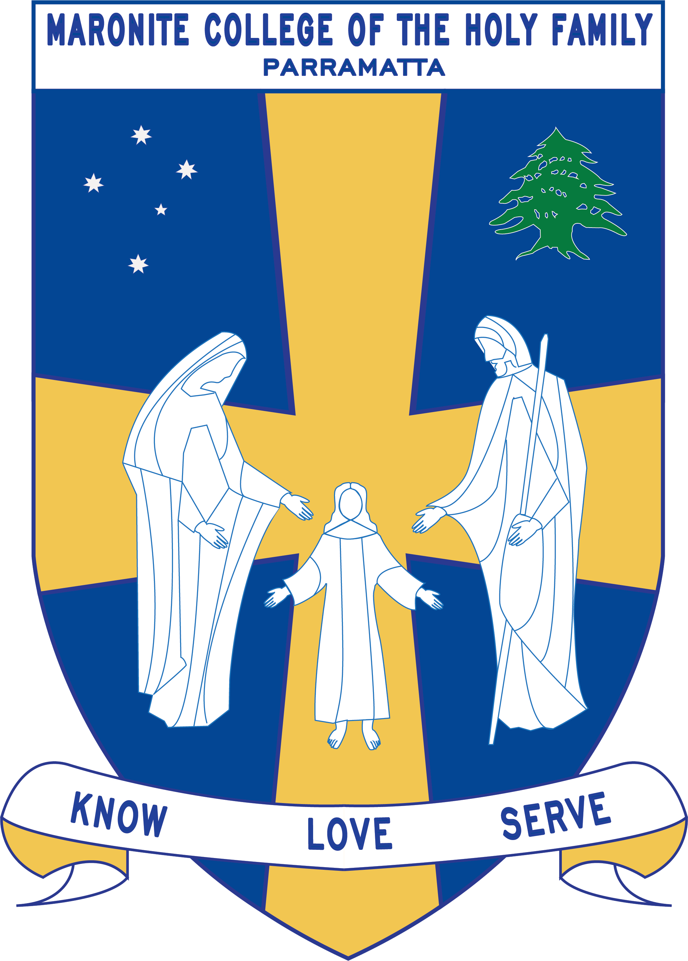

Grade Curriculum Notes: Kindergarten

2019

Teaching Staff

Grade: Kindergarten

Stage Coordinator: Mrs Vrontas
Special Needs Coordinator: Mr Perret
Grade Teachers : Ms Bechara
Ms Alweddy
Ms Delos Reyes
Ms Hanna

Arabic Teachers: Mrs Chalhoub
Mrs Farah
Mrs Zaiter
Mrs Sassine

Learning Centre Supervisor: Ms Le Merle

Integration/EAL Staff: Ms Pantelone
Ms Maxwell

Learning Support: Katie Zdrilic

Curriculum Notes
Homework:

Each term the children will receive a homework grid focusing on English, Mathematics, Religion and Physical Education concepts. Students also receive a home reader and high frequency words that are to be completed every night. This goes home on the Monday and is to be returned on the Friday.

English/Mathematics:
Some of the key concepts covered in English and Mathematics include:

English

- Recites known nursery rhymes
- Use correct grammar when speaking to others
- Following directions and instructions
- Use knowledge of sounds (phonics) when reading and writing
- Reads irregular (tricky) words as a sight word list
- Understand what they have read
- Progress through leveled books at an individual rate
- Writes letters of the alphabet using the correct NSW Foundation Style letter formation
- Writes different types of texts (recount, information reports, descriptions, narratives)
- Uses capital letters, full stops and word spacing in the writing experience

Mathematics

- Counting, recognising and labelling groups of objects to 10
- Recognising number names to twenty
- Counting to 30; recognising numbers to 20; counting and labelling to 20
- Numbers before and after a given number; counting on from a given number
- The beginnings of addition (joining) and subtraction (taking away)
- The beginnings of multiplication (grouping) and division (sharing)
- Counting by two and five as a number pattern
- Creating and reading information from picture graphs
- Time: reading o’clock times on digital and analogue clocks, morning/night/afternoon, yesterday/today/tomorrow, days of the week, months of the year
- Shapes and shape names

Integrated Units: The following units are covered throughout the year:

 | Term 1 | Term 2 | Term 3 | Term 4
Religion | - Lent / Easter  - God Loves Me | My Family Loves Me | God Is Our Creator | - The Community That Celebrates God  - Christmas  - Jesus Is Born
Science and Technology/History/  Geography | Science:  Earth & Space Sciences: Weather in my World  Physical Sciences: On The Move | History:  Personal and Family Histories | Science:  Chemical Sciences: What’s it made of?  Biological Sciences: Staying Alive | Geography:  People live in places
Creative Arts | Creative Arts is integrated with thematic units
PDHPE | Physical Education Gymnastics  -Non-locomotor & Locomotor skills  - Elements of Movement and Composition.  Personal Development & Health  Personal Health Choices  - The students will be learning about the various ways in which they can make decisions which will influence their health in the areas of nutrition, health services and products, drug use, environmental health and preventative measures. | Physical Education Athletics and Active Lifestyle  This term the students will be focusing on Athletics (Games and Sports- Athletics) including the skills of running, jumping and throwing.  -They will also look at Ways to be Active through playing ball games and participating in obstacle courses.  Personal Development & Health  Safe Living  -Students will cover content on various Safety measures that need to be taken at school, home, rural, road, water, personal safety and will also learn about what to do in case of an Emergency.  Active Lifestyle- Components of an Active Lifestyle and the Effects of Physical Activity will also be taught this term. | Physical Education Minor Games  The students will actively participate in minor games including: miming/imitating, running, chasing, circle, simple ball games, cooperation games and parachute games.  Personal Development & Health  Interpersonal Relationships  - This term the students will learn about Relationships, Communication, Families, Peers and Groups. This will look at communicating feelings, developing positive relationships, working and playing with others. | Physical Education  Dance  The students will learn various dance styles, including folk, social, bush and creative. This will focus on developing appropriate non-locomotor and locomotor skills and will look at elements and compositions of various dances.  Personal Development & Health  Growth and Development  - This term the students will be learning about their Personal Identity, the different parts of the body including their senses and changes that occur from birth. They will also discuss Values, looking at likes, dislikes, acceptance of people’s uniqueness and differences.

Below are the allocated times for specialist classes:

 | Kinder White | Kinder Red | Kinder Blue | Kinder Rose
Learning Centre | Tuesday  (Borrowing Day Thursday) | Tuesday  (Borrowing Day Thursday) | Wednesday  (Borrowing Day Thursday) | Monday  (Borrowing Day Thursday)
Arabic | Daily 11:20-11:50 | Daily 11:20-11:50 | Daily 11:20-11:50 | Daily 11:20-11:50
Sport | Wednesday | Wednesday | Wednesday | Wednesday
ICT | Monday | Tuesday | Thursday | Wednesday

Kindergarten - Term 3 Overview 2018

This is a term overview for the teaching and learning for each subject in Kindergarten for Term 3.

KLA | Outcome Description | Unit Outline
English  Mathematics  Religion  Geogrpahy  Personal Development, Health & Physical Education  Creative Arts | English  ENe-1A Communicates with peers and known adults in informal and guided activities demonstrating emerging skills of group interaction  ENe-2A Composes simple texts to convey an idea or message  ENe-3A Produces most lower case and upper case letters and uses digital technologies to construct texts  ENe-4A Demonstrates developing skills and strategies to read, view and comprehend short, predictable texts on familiar topics in different media and technologies  ENe-5A Demonstrates developing skills in using letters, simple sound blends and some sight words to represent known words when spelling  ENe-6B Recognises that there are different kinds of spoken texts with specific language features and shows an emerging awareness of some purposes for spoken language  ENe-7B Recognises some different purposes for writing and that own texts differ in various ways  ENe-8B Demonstrates emerging skills and knowledge of texts to read and view, and shows developing awareness of purpose, audience and subject matter  ENe-9B Demonstrates developing skills and knowledge in grammar, punctuation and vocabulary when responding to and composing texts  ENe-10C  thinks imaginatively and creatively about familiar topics, simple ideas and the basic features of texts when responding to and composing texts  ENe-11D  responds to and composes simple texts about familiar aspects of the world and their own experiences  ENe-12E  demonstrates awareness of how to reflect on aspects of their own and others’ learning  Number and Algebra  Whole Number  MAe-4NA Counts to 30 and orders, reads and represent numbers 0 to 20.  Money  MAe-4NA Counts to 30 and orders, reads and represent numbers 0 to 20.  Addition and Subtraction  MAe-5NA Combines, separates and compares collections of objects, describes using everyday language, and records using informal methods.  Multiplication and Division  MAe-6NA Groups, shares and counts collections of objects, describes using everyday language and records using informal methods  Measurement and Geometry  Area  MAe-10MG Describes and compares area using everyday language.  Volume and Capacity  MAe-11MG Describes and compares the capacities of containers and the volumes of objects or substances using everyday languages.  Mass  MAe-12MG Describes and compares the masses of objects using everyday language  Three-Dimensional Space  Mae-14MG Manipulates, sorts and represent three dimensional objects and describes them using everyday language.  God’s Creation  The focus is on God being our creator. The topics studied follow the Sharing Our Story document developed by the Catholic Education Office, Diocese of Parramatta.  O1 – God Demonstrate an  understanding and appreciation of God  as our loving creator, ever-present and  experienced in people and the world  around us.  O2 – Jesus Demonstrate an  understanding and appreciation of Jesus  as the incarnate Son of God who loves  us and invites us to grow in relationship  with him.  O3 – Church Demonstrate an  understanding and appreciation of the  Church as a special community  described as God’s family.  O4 – Sacraments Demonstrate an  understanding and appreciation of the  Church’s sacraments as sacred actions  by which we are welcomed to  community, reconciled and invited to  share the special presence of Jesus.  GEe-1: Identifies places and develops an understanding of the importance of places to people.  GEe-2: Communicates geographical information and uses geographical tools.  Growth & Development  GDES1.9 Identifies how people grow and change  DMES1.2 Identifies some options available when making simple decisions.  V1-refers to a sense of their own worth and dignity  V4- increasingly accepts responsibility for personal and community health ·  Interpersonal Relationships  IRES1.11 Identifies how individuals  care for each other  INES1.3 Relates well to others in work  and play situations  V1-refers to a sense of their own worth  and dignity  V2- respects the right of others to hold  different values and attitudes from their  own  V3 - enjoys a sense of belonging.  GSES1.8 – demonstrates fundamental movement skills while playing with and sharing equipment  MOES1.4 - demonstrates a general awareness of how basic movement skills apply in play and other  introductory movement experiences  DAES1.7 – moves in response to various stimuli  V2- respects the right of others to hold different values and attitudes from their own  V3 - enjoys a sense of belonging.  V4 – Increasingly respects responsibility for personal and community health  V5 - willingly participates in regular physical activity  Visual Arts  Making  VAES1.1 Makes simple pictures and other kinds of artworks about things and experiences.  VAES1.2 Experiments with a range of media in selected forms.  Appreciating  VAES1.3 Recognises some of the qualities of different artworks and begins to realise that artists make artworks.  VAES1.4 Communicates their ideas about pictures and other kinds of artworks.  Drama  Making  DRAES1.1 Uses imagination and the elements of drama in imaginative play and dramatic situations.  Performing  DRAES1.3 Dramatises personal experiences using movement, space and objects.  Appreciating  DRAES1.4 Responds to dramatic experiences.  Music  Performing  MUES1.1 Participates in simple speech, singing, playing and moving activities, demonstrating an awareness of musical concepts.  Organising Sound  MUES1.2 Creates own rhymes, games, songs and simple compositions.  Listening  MUES1.4 Listens to and responds to music. | The Daily Literacy Block  Learning Intention and Success Criteria  Co-constructed with the students and displayed in the classroom for daily reference and built upon as the students develop their reading strategies.  Read from left to right  - Look at the illustrations  - Follow the words  - Think about what you are reading  - Re-read and read on to build on understanding  - Use a combination of graphophonic, syntactic and semantic knowledge from the text to read  Success criteria for writing includes:  - We write to express an idea or convey a message  - Write from left to right  - Use finger spaces  - Use the word wall  - Sound out new words  - Start with a capital letter  - End with a full stop  Read Aloud  Premier Reading Challenge picture books  Each morning at the start of the literacy block the students will engage in listening to the teacher read a text from the 2019 Premier’s Reading Challenge collection during their crunch and sip time.  Shared Reading  Students and teacher engage in the explicit reading of the text each day.  Teacher demonstrates the skills that have been listed in the Success Criteria to build the beginning reader’s reading strategies.  Purposeful Talk  Students will engage in a variety of opportunities throughout the day to build upon their oral literacy skills.  Modelled Writing  The teacher will:  - Demonstrate the use of the Word wall to locate vocabulary the writer can use in their writing.  - Demonstrate elementary punctuation used when writing sentences, using the shared reading text as a mentor text show how author’s use punctuation in their writing - Capital letters and full stops.  - Teacher models writing skills including – spelling, editing, sentence beginnings, page orientation, spacing between words.  Independent Writing Each day the students will complete an independent writing task (often this is based on the shared reading text. The students are encouraged to apply the writing skills they have been explicitly taught in the daily a modelled writing session.  Guided Reading Each day the students will have the opportunity to read in a small group with the teacher. (15-20mins)  Independent Reading Students are given the opportunity to read familiar texts and unfamiliar texts throughout the literacy block as well as throughout the day in other KLAs.  Phonics Each day the students will listen to the jolly phonics song and learn the letter sounds and names.  Students will:  - count forwards to 30.  - counts with one to one correspondence.  - write numbers to 30 using numerals.  - present numbers to 10 using dot patterns and objects.  - sequence numbers to 30.  - students use the calculator to play a number guessing game.  - students sequence and record events using ordinal numbers.  - Students will recognize that there are different coins and notes in our monetary system.  - Students will exchange money for good in a play situation.  - Addition: Joins two groups of objects and states the total number.  - Subtraction: Takes part of a group of objects away and states the number of objects remaining.  - Counts forwards by ones to add and backwards by ones to subtratct.  - Creates and recognise combinations for numbers to 10 (Friends of 10)  - Multiplication: Illustrates rows/groups of objects.  - Students share and divide objects into equal parts  Students will continue to play Count Me In Too games in number lesson to reinforce counting, number recognition, sequencing and dot patterns.  Students measure an area using informal measurement.  Students recognise and compare when a container is full, empty and about half full.  Different containers will be used to measure volume.  Children predict and measure objects using hefting and equal arm balance.  Students sort, describe and name familiar three dimensional objects in the environment.  Concepts covered are:  - Creation of the world.  - How we can care for God’s creation.  - The world God has made around us.  - God has made us an individual.  Students will:  Investigate the importance of places they live in and belong to. · Discuss why places are special and how people care for them · Explain why people need to take care of places Aboriginal and Torres Strait Islander places  Students will: · Investigate the Country/Places important to Aboriginal or Torres Strait Islander · Discuss why the site, Country or Place is important Locating places  Students will · Investigate how the location of places can be represented, for example: Location of familiar and local places on maps · Describe the location of places  Personal Development and Health - Interpersonal Relationships is concerned with developing an understanding of the nature of relationships. Students develop skills for building positive responsible relationships, and practise their application so that they can use them effectively in their lives. The students will learn about Relationships, Communication, Families, Peers and Groups. This unit will look at communicating feelings, developing positive relationships, working and playing with others.  Physical Education - The students will actively participate in minor games including: miming/imitating, running, balancing, chasing, circle, simple ball games, cooperation games and parachute games.  Visual Arts - Students develop knowledge and understanding, skills, values and attitudes in Making and Appreciating by engaging with the concepts of artists, artworks, the audience and the world.  Drama - Students will develop knowledge and understanding, skills, values and attitudes in Making, Performing and Appreciating by engaging in role, dramatic contexts, elements and forms. In making drama, students learn how to investigate their world through devising plays, role-plays and imagined situations.  Music  In Music, students develop knowledge and understanding, skills, values and attitudes in Performing, Organising Sound and Listening by experiencing musical concepts (duration, pitch, dynamics, tone colour, and structure) within a wide range of Repertoire through a sequential and planned process of teaching and learning.

