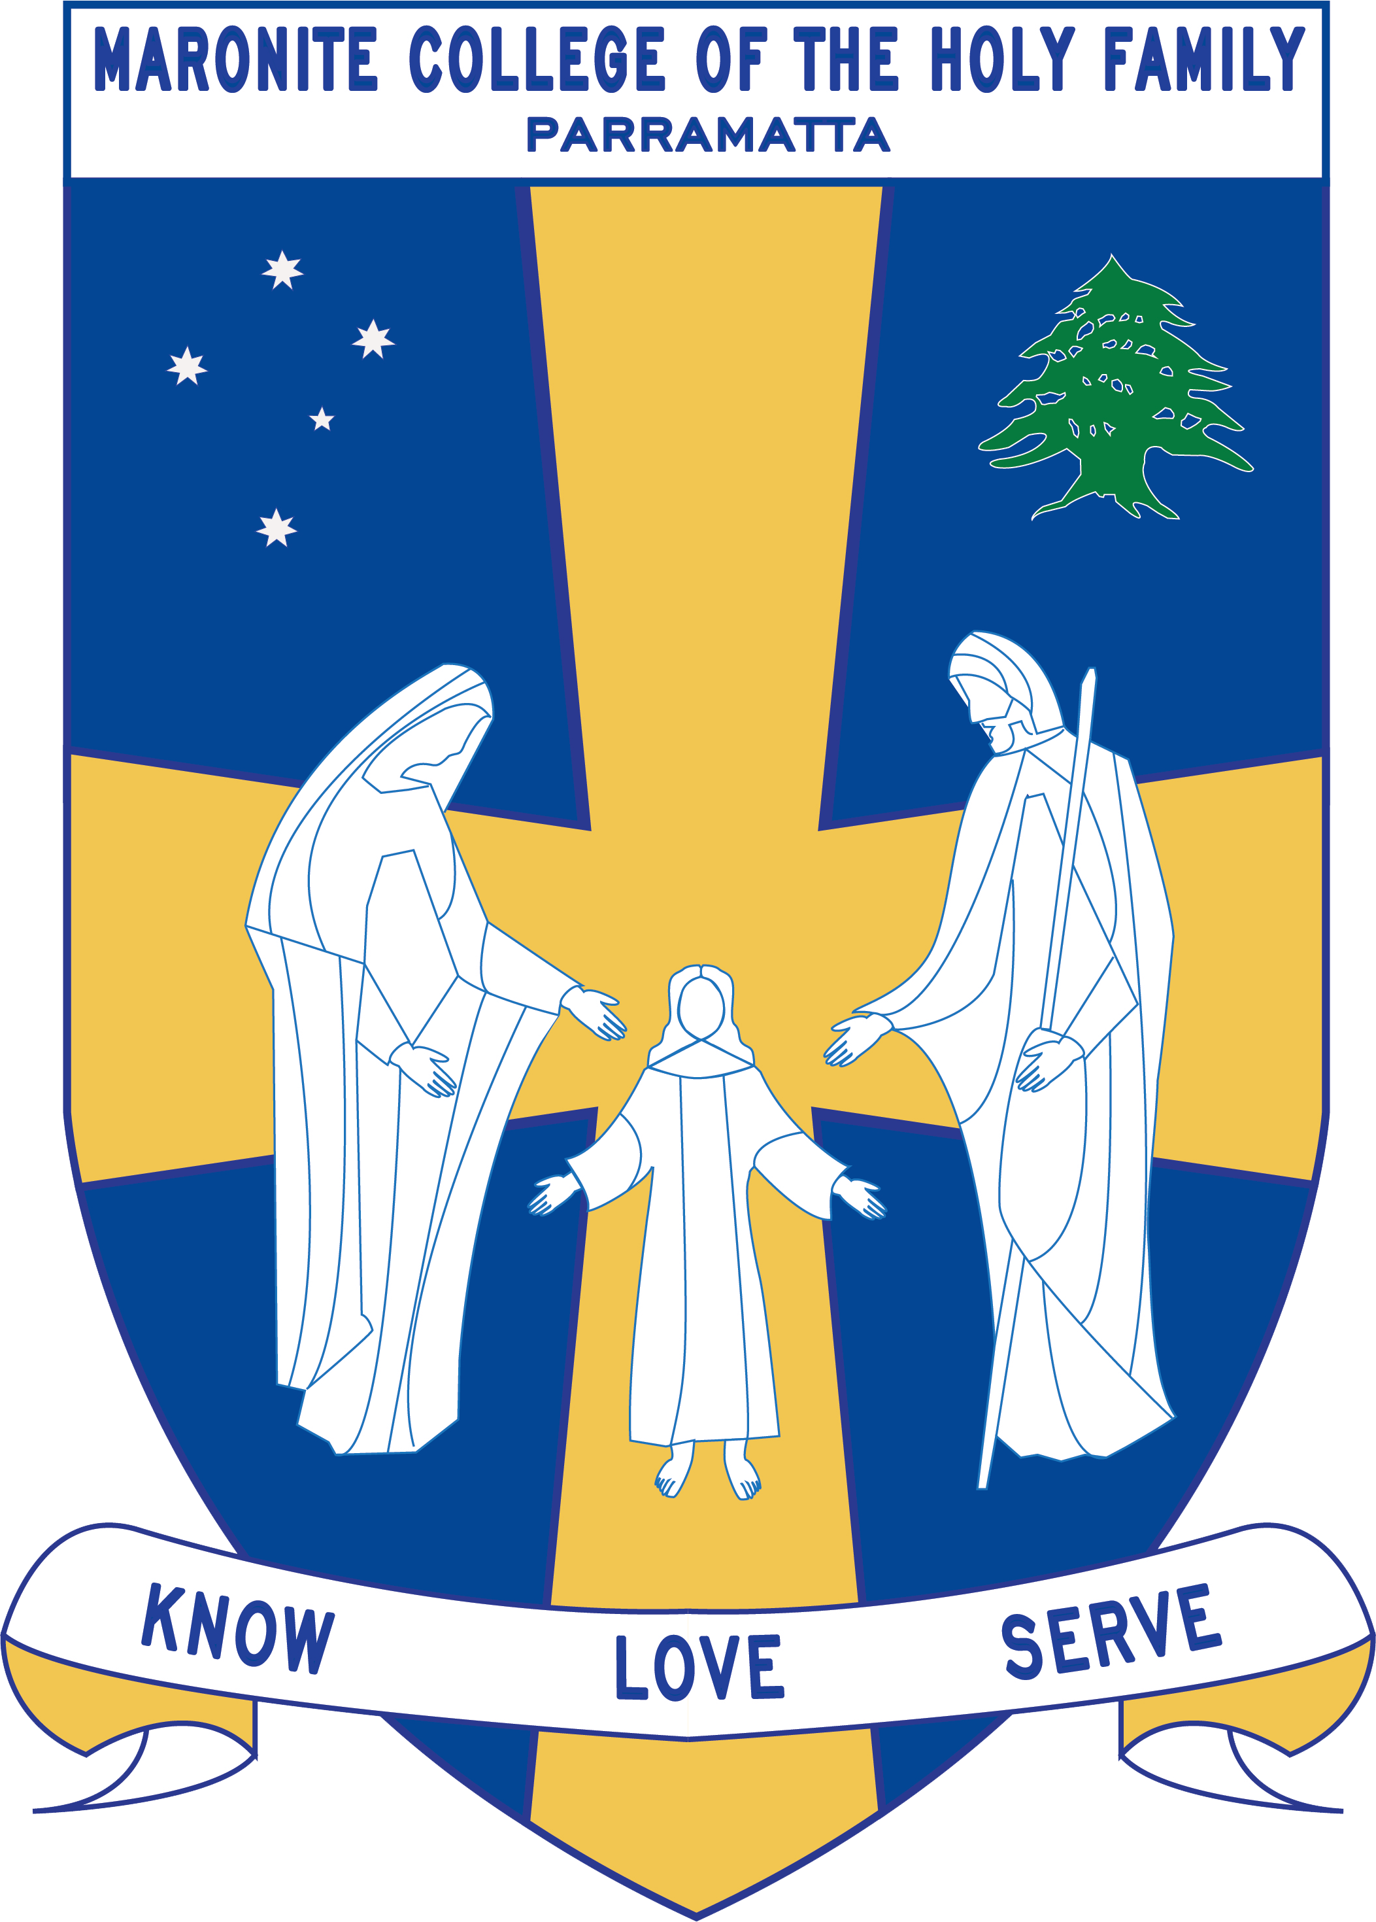
Howayek Providence Limited trading as
Maronite College of the Holy Family

Kindergarten Term 3 Overview 2020

Dear Parents and Guardians,

Welcome to Term 3. Listed below is a summarised outline of the topics and content we will be covering in our grade. Information pertaining to all other aspects of the grade has also been included to help you organise and support your child’s learning.

Teaching Staff
Head of Primary | Mr Dean Day
Stage Coordinator K-2 | Mrs Vrontas
Class Teachers | Miss Alweddy - K Rose  Miss Bechara – K Blue  Mrs Delos Reyes - K White  Mrs Saap - K Red
Special Needs Coordinator | Mr Christopher Perret
Integration Teacher/s | Mrs Pantaleone/ Mrs Dagher
Teacher Assistant | Mrs Ghabache
Learning Centre Coordinator | Ms Anne LeMerle
Arabic Staff | Mrs Marie Zaiter  Mrs Laura Chalhoub  Mrs Francine Farah  Mrs Therese Sassine

Daily Routines
Monday | Kinder Rose – Learning Centre  Kinder White – ICT  Arabic for all classes – 11:20-11:50
Tuesday | Kinder White – Learning Centre  Kinder Red- Learning Centre  Kinder Red- ICT  Arabic for all classes – 11:20-11:50
Wednesday | All Kindergarten - Sport Day – Wear Summer sport uniform  Kinder Blue – Learning Centre  Kinder Rose – ICT  Arabic for all classes – 11:20-11:50
Thursday | All Kindergarten- Library Borrowing  Kinder Blue- ICT  Arabic for all classes – 11:20-11:50
Friday | Arabic for all classes – 11:20-11:50

Important Information
- Student Absences – A note or medical certificate is required when a student is absent from school. For prolonged illness, notification to the main office is also required.
- Parent and Teacher Meetings - All communication with teachers is to be conducted via phone or email through the Primary Office. Alternatively, you can write a brief note for your child to pass on to their teacher. At no time should a parent approach another student or parent, either at school or outside the College grounds regarding an issue relating to their child. These issues must also be raised at the Main Office so that the situation can be referred to the appropriate staff member. Following the correct procedure will ensure that any concern is addressed promptly.
- Homework – Your child is to hand in their red homework folder every Friday to their class teacher
- Parent Volunteer – There will be not Parent Volunteers permitted this term due to Covid-19

Curriculum Overview
Key  Learning Area | Unit Outline
Religion | Students will demonstrate an understanding and appreciation of God as our loving creator, ever-present and experienced in people and the world around us.  Students will demonstrate an understanding and appreciation of Jesus as the incarnate Son of God who loves us and invites us to grow in relationship with him.  Maronite Component  Saint Charbel’s Feast Day -Feast day - 17th July  Assumption of the Blessed Mary - Feast Day- 15th August  Exaltation of the Cross - Feast Day- 14th September
English | Students will be engaged in the daily literacy block each morning where they will read, write, listen and talk. Quality independent tasks have been designed to reinforce the vocabulary and comprehension of the shared big book.  - Participate in daily Guided Reading groups  - Develop an awareness of letter sounds and names  - Begin to use letter sound knowledge to spell simple words  - Develop quick recall of simple sight vocabulary  - Develop beginning reading skills and recognise that letters are joined together to make words  - Develop basic skills of writing, including correct pencil grip, good posture and form upper and lower case letters  - Recognise simple words in familiar texts and use them in their writing  - Engage in purposeful talk about their work and the shared reading text
Mathematics | Students will be engaged in daily maths activities that focus on the use of concrete materials to explore and informally record beginning maths concepts.  - Division  - Multiplication  - Addition  - Subtraction  - Whole number – money  - Whole number  - Volume and Capacity  - Three-Dimensional Shapes  - Area and mass
History/Geography/  Science & Technology | Unit: Places and People  Students will:  Explore the places they live in and belong to.  Develop an understanding of what makes a place special and how this may differ for different people.  Learn about the importance of looking after places.  Students explore how the location of places can be represented.
Personal Development, Health and Physical Education | Unit: How can I be safe?  Students explore ways of keeping themselves safe across different contexts including protective strategies and people they can trust. They identify situations where they could use these strategies to keep themselves safe.  Unit: How can I move in different ways?  Students explore ways to move and balance in response to stimuli. There is a strong focus on moving to music and the integration of different locomotor, stability and manipulative skills. They explore static and dynamic balance through individual and group-based activities. Students develop fundamental movement skills and explore how they can be integrated with the dominant movement patterns identified in gymnastic-style activities.
Creative Arts | Visual Arts  In Visual Arts, students develop knowledge and understanding, skills, values and attitudes in Making and Appreciating by engaging with the concepts of artists, artworks, the audience and the world.  Drama  In Drama, students will develop knowledge and understanding, skills, values and attitudes in Making, Performing and Appreciating by engaging in role, dramatic contexts, elements and forms. In making drama, students learn how to investigate their world through devising plays, role-plays and imagined situations.  Music  In Music, students develop knowledge and understanding, skills, values and attitudes in Performing, Organising Sound and Listening by experiencing musical concepts (duration, pitch, dynamics, tone colour, and structure) within a wide range of Repertoire through a sequential and planned process of teaching and learning.

