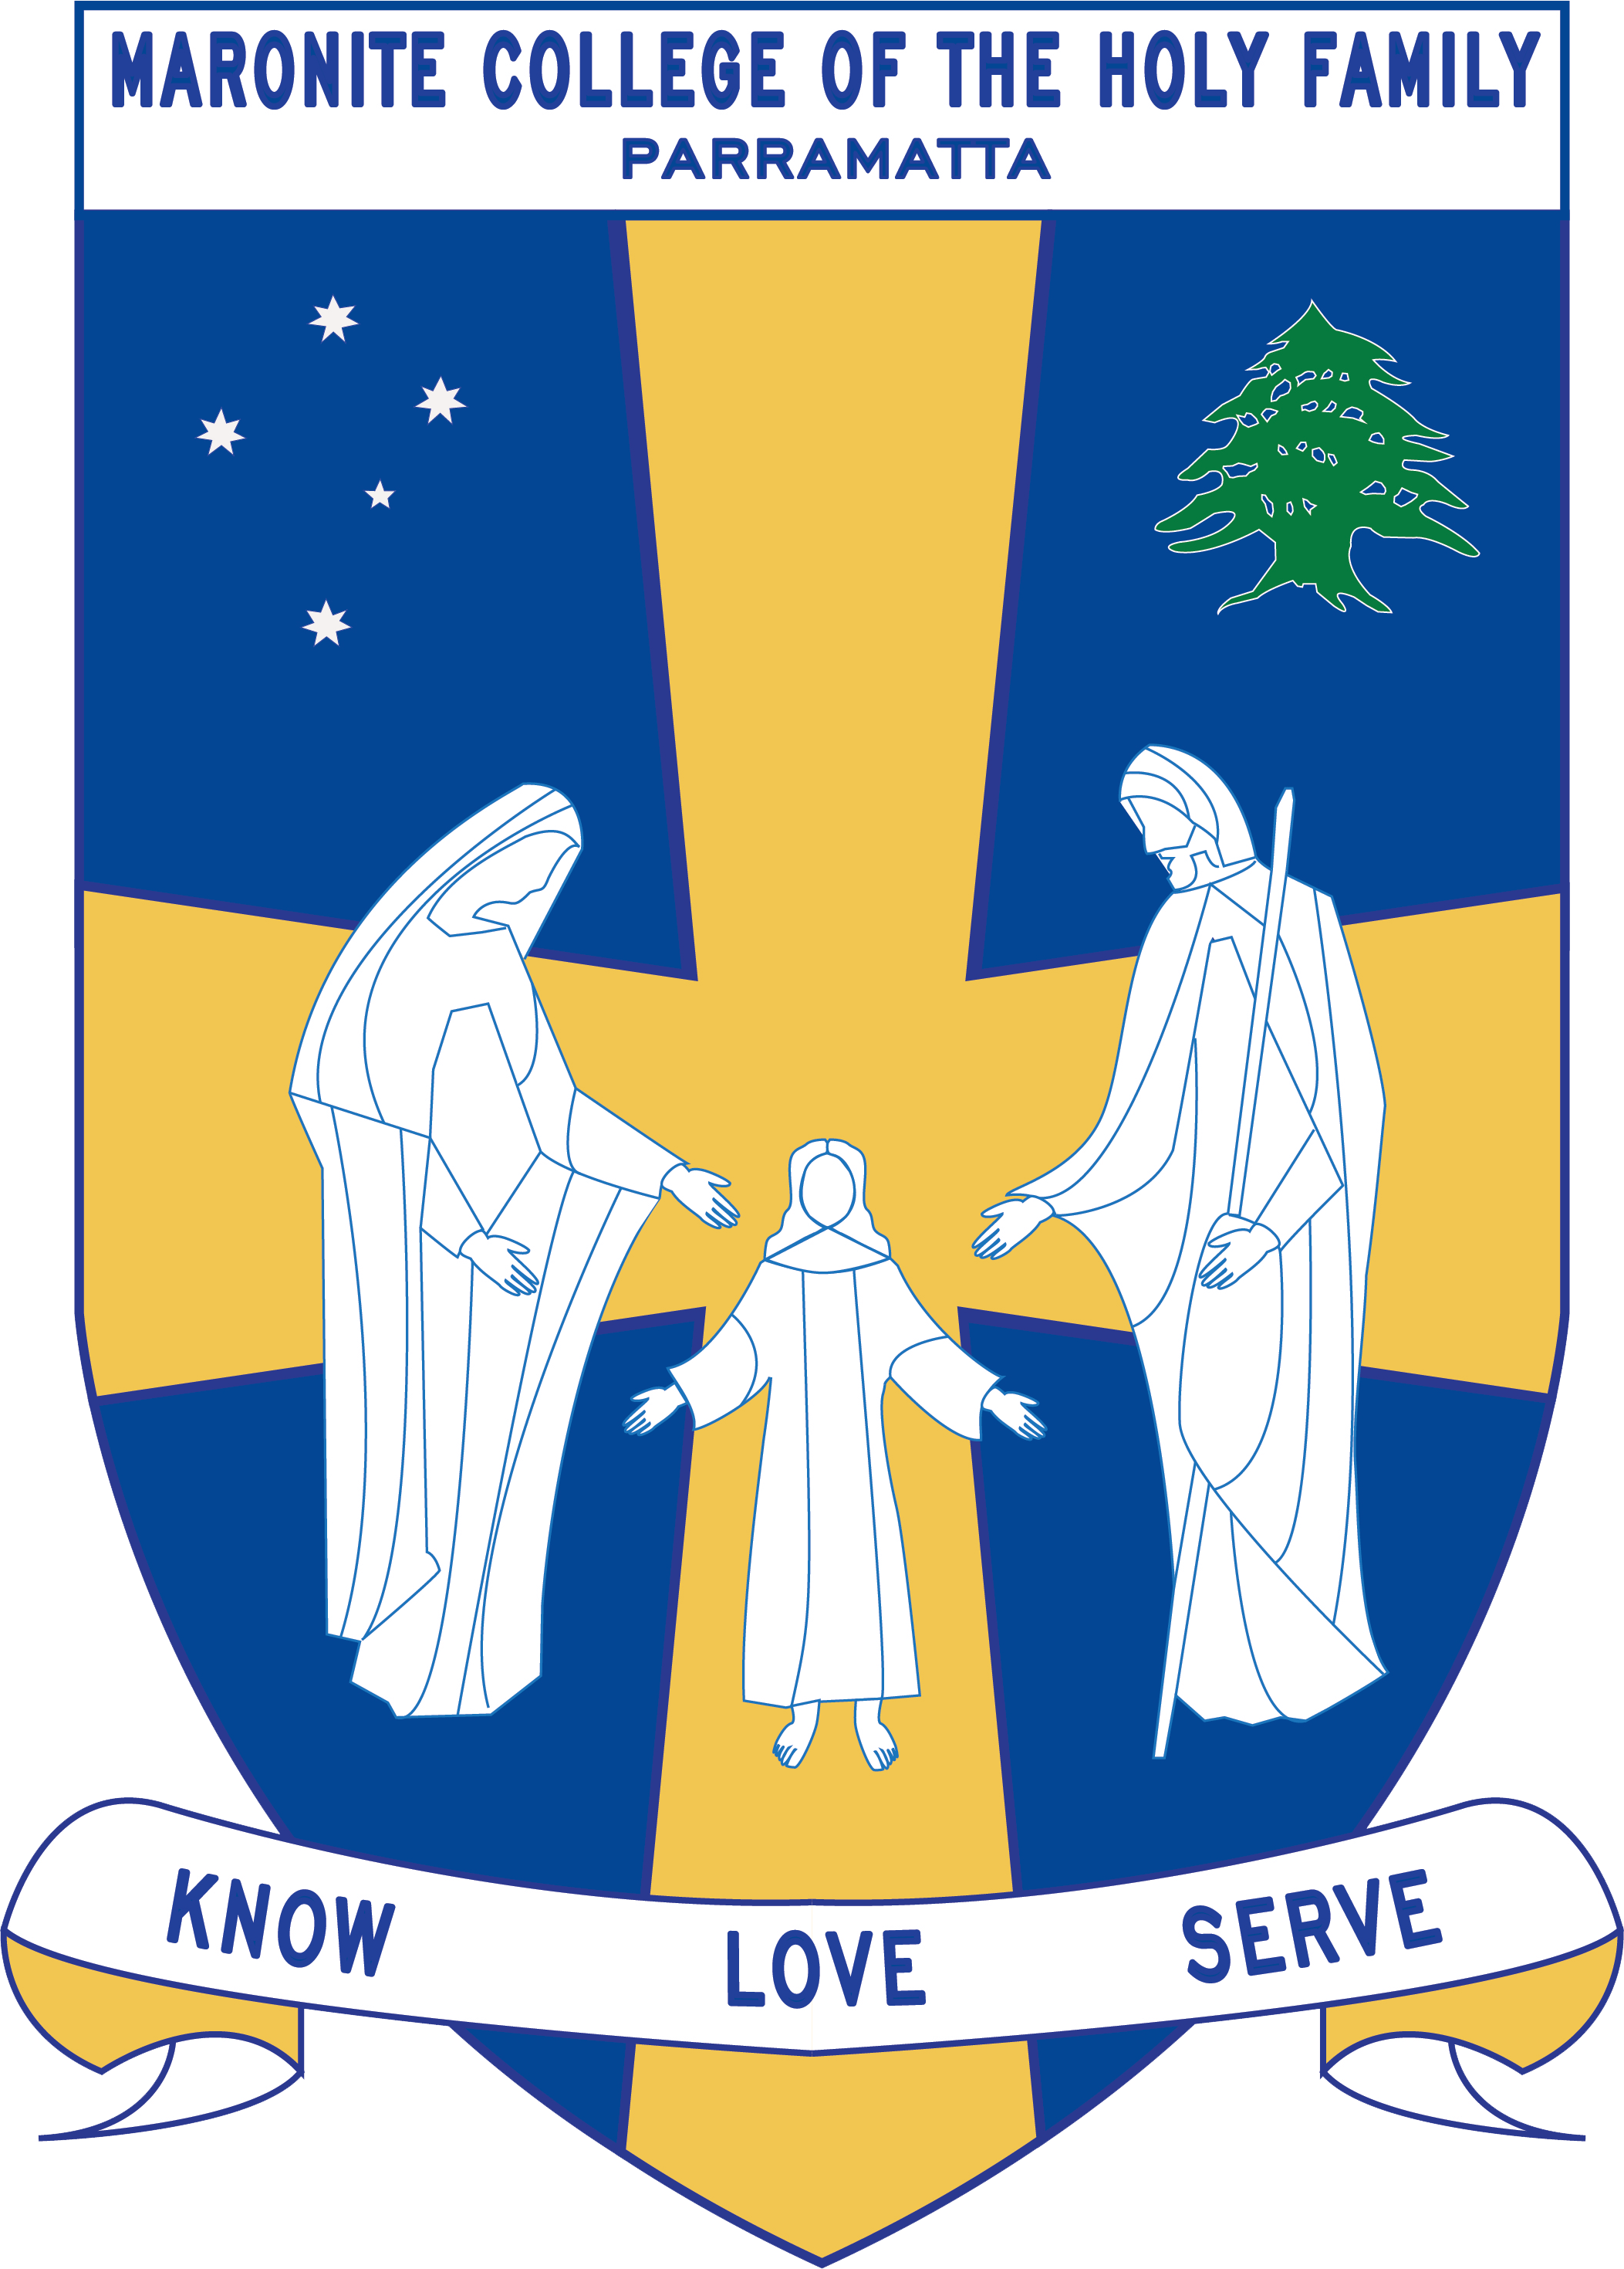
Howayek Providence Limited trading as
Maronite College of the Holy Family

Year 3 Term 3 Overview 2020

Dear Parents and Guardians,

Welcome to Term 3. Listed below is a summarised outline of the topics and content we will be covering in our grade. Information pertaining to all other aspects of the grade has also been included to help you organise and support your child’s learning.

We look forward to working in collaboration with you throughout year.

Teaching Staff
Head of Primary | Mr Dean Day
Stage Coordinator | Mr Anthony Bechara
Class Teachers | Mrs Bridgette Ramsey 3 Beige  Ms Sue Monday 3 Lavender  Ms Souad Assaf 3 Yellow  Mr John Munce 3 Orange
Special Needs Coordinator | Mr Christopher Perret
Integration Teacher/s | Mrs Suzy Lal
Support Teacher/s | Mrs Emma Nemer and Mrs Giselle Harb
Learning Centre Coordinator | Ms Anne LeMerle
Arabic Staff | Mrs Marie Zaiter  Mrs Laura Chalhoub  Mrs Francine Farah  Mrs Therese Sassine

Daily Routines
Monday | Library Borrowing: 3 Lavender ; ICT:3 Beige
Tuesday | Library Borrowing: 3 Orange, 3 Yellow; ICT: 3 Lavender
Wednesday | Sport : All Year 3 Classes; ICT: 3 Orange; Library Borrowing: 3 Beige
Thursday | Library Borrowing: 3 Beige
Friday | ICT: 3 Yellow

Important Information
- Student Absences – A note or medical certificate is required when a student is absent from school. For prolonged illnesses, notification to the main office is also required. When your child is absent from school please send a prompt note to the classroom teacher on their return to school.
- Parent and Teacher Meetings - All communication with teachers is to be conducted via phone or email through the Primary Office. Alternatively, you can write a brief note for your child to pass on to their teacher. At no time should a parent approach another student or parent, either at school or outside the College grounds regarding an issue relating to their child. These issues must also be raised at the Main Office so that the situation can be referred to the appropriate staff member. Following the correct procedure will ensure that any concern is addressed promptly.
- Borrowing – Please ensure all students have their library bags on their given Library Borrowing day.
- Homework – Homework is compulsory and is based on Reading Eggs and Maths on-line. If your child is unable to complete their homework due to unforeseen circumstances, please provide a note to their classroom teacher.
- Money Collection – When sending any money to school with your child please ensure that it is in a sealed envelope with your child’s name clearly written on it.
- Crunch and Sip – As part of our daily routine students eat a piece of fruit and/or vegetable every morning, with plenty of water to drink. Please provide this for your child each day.
Curriculum Overview
Key Learning Area | Unit Outline
Religion | Mary: A Woman of Faith 23C6  Students will explore gospel stories which tell of Mary’s faithfulness. They will be encouraged to learn from the example of Mary and her response to God. Students will have opportunities to honour Mary through liturgy and prayer.  Reaching Out with Jesus 23E  In this unit students will explore the nature and challenges of Christian missions through their study of Jesus’ instructions to the apostles in, The Mission of the Twelve Disciples. There is an emphasis on students applying this understanding of the mission to the global reality.
English | The students will listen to, read, view, discuss, interpret and create Imaginative, Informative and Persuasive tests with a focus on describing settings and characters and complex sequences of events.  The students will use different text structures depending on the purpose of the text. They will use language features, images and vocabulary.  They will read texts that contain varied sentence structures, a range of punctuation conventions, and images that provide additional information. The main text that will initially be read is Piggy Book by Anthony Browne. Many other texts will be read over the course of the term.  They will use grammar and choose vocabulary and punctuation appropriate to the purpose and context of their writing.  They will identify literal and implied meaning connecting ideas in different parts of a text. They will select information, ideas and events in texts that relate to their own lives and to other texts.  They will listen to others’ views and respond appropriately. Students will use language features to link and sequence ideas.  They will use language to express feelings and opinions on differing topics. Students to create a range of texts for familiar and unfamiliar audiences.  They will contribute actively to class and group discussions, asking questions, providing useful feedback and making presentations.
Mathematics | Students will be assessed on the following topics at the end of each unit through teacher observations, student work samples, teacher dialogue with students, completion of written tasks and topic tests.  Measurement and Geometry- Time  In this unit of work, students will engage in a range of practical activities that teach them how to tell time to the minute and investigate the relationship between units of time. They will recognise the coordinated movements of the hands on an analog clock, read analog and digital clocks to the minute, including using the terms ‘past’ and ‘to’ and record in words various times shown on analog and digital clocks.  Number and Algebra- Multiplication and Division  In this unit of work, students will focus on representing and solving problems involving multiplication using efficient mental and written strategies and appropriate digital technologies. They will learn to select, use and record a variety of mental strategies, and appropriate digital technologies, to solve simple multiplication problems, pose multiplication problems and apply appropriate strategies to solve them, explain how an answer was obtained and compare their own method of solution with the methods of other students as well as explain problem-solving strategies using language, actions, materials and drawings.  Measurement and Geometry- Mass  Students will be investigating problem solving strategies, calculating missing mass and allocating appropriate units to objects.  Measurement and Geometry – Volume & Capacity  Students will be investigating problem solving strategies, calculating missing volume or capacity of shapes and containers and allocating appropriate units to best measure containers.  Statistics and Probability- Chance  Students will be investigating problem solving strategies, conducting chance experiments, listing all possible outcomes in chance situations and using appropriate terminology in this unit.
History/Geography/  Science & Technology | History - Community and Remembrance  This unit provides a study of identity and diversity in both a local and broader context. Moving from the heritage of the local Parramatta area, students will explore the historical features and diversity of their community. They will research and discover information about the Darug people and the impact of British colonisation on their lives in the past and the present. They will research and discover details about the changes that have taken place in the local and broader community. They will examine local, state and national symbols and emblems of significance, and celebrations and commemorations, both locally and in other places around the world.
Personal Development, Health and Physical Education | Health:  How do I look after myself and others?  Students will participate in a range of activities and explore what can contribute towards the positive mental health of everyone in their community including themselves. There is a focus of developing and applying self-management skills. Students will investigate the importance of these skills when participating in physical activity.  Physical Education:  How do we explore different movement patterns?  Students will explore a range of movement skills to complete movement challenges and to create new sequences. Movement sequences are created and performed while further developing interpersonal skills through collaborative decision-making. Students participate in activities that explore movement patterns related to gymnastics as well as the elements of dance.
Creative Arts | Students will be participating in a range of activities that will enhance their understanding and ability in the areas of Music, Visual Arts and Drama.  Weeks 1-5 – Visual Art  Art experience is based on the text ‘Where the Forest Meets the Sea’ by Jeannie Baker. Students will use this text and prior knowledge to formulate a collage of what they describe the forest to look like. Students will be using items collected on a walk and other suitable items found at home to construct their three-dimensional artwork. Throughout the text the concept of deforestation is present and therefore this has affected the animals.  Students will create an Aboriginal dot painting using an outline of an extinct animal.  Weeks 6-10 - Dance  Students will engage in a variety of dance elements such as time, actions, dynamics space, relationships and structure. Students will recognise the importance of dance within the Aboriginal traditions and customs.

