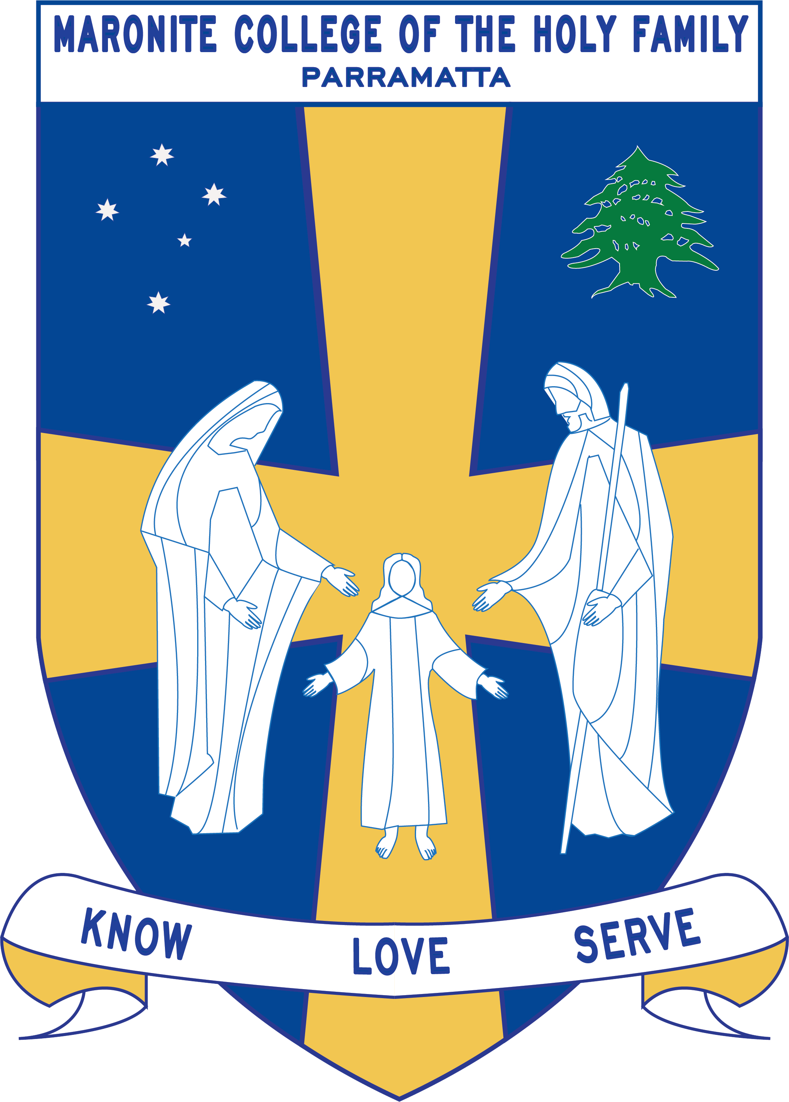
Howayek Providence Limited trading as
Maronite College of the Holy Family

Year 6 - Term 3 Overview 2020

Dear Parents and Guardians,

Welcome to Term 3. Listed below is a summarised outline of the topics and content we will be covering in our grade. Information pertaining to all other aspects of the grade has also been included to help you organise and support your child’s learning.

We look forward to working in collaboration with you throughout year.

Teaching Staff
Head of Primary | Mr Dean Day
Stage Coordinator | Ms Rozario
Class Teachers | Ms Lamia Mourched – 6 Emerald  Mrs Laurise Dasouqi – 6 Topaz  Mr John Watkiss – 6 Teal  Ms Hannah Mourani – 6 Indigo
Special Needs Coordinator | Mr Christopher Perret
Integration Teacher/s | Mrs Anne Maxwell
Support Teacher/s | Ms Waffa Moussa
Learning Centre Coordinator | Ms Anne LeMerle & Ms Kate Hort
Arabic Staff | Mrs Marie Zaiter  Mrs Laura Chalhoub  Mrs Francine Farah  Mrs Therese Sassine

Daily Routines
Monday | 6 Indigo – Library Borrowing  6 Emerald - ICT
Tuesday | 6 Topaz – Library Borrowing  6 Indigo – ICT
Wednesday | 6 Emerald – Library Borrowing  6 Teal -ICT
Thursday | 6 Topaz – ICT  6 Indigo & 6 Topaz – Learning Centre
Friday | 6 Teal – Library Borrowing  6 Teal & 6 Indigo – Learning Centre  Year 6 Sport

Important Information
- Student Absences – A note or medical certificate is required when a student is absent from school. For prolonged illness, notification to the main office is also required.
- Parent and Teacher Meetings - All communication with teachers is to be conducted via phone or email through the Primary Office. Alternatively, you can write a brief note for your child to pass on to their teacher. At no time should a parent approach another student or parent, either at school or outside the College grounds regarding an issue relating to their child. These issues must also be raised at the Main Office so that the situation can be referred to the appropriate staff member. Following the correct procedure will ensure that any concern is addressed promptly.
- Homework: Your Year 6 child should be spending a minimum of 60 minutes on homework each school night. Students are required to complete Maths Online, Reading Eggs, spelling and Arabic homework each night. They will also record homework tasks, assessments and assignments in their college diary which must be brought to school with them each day. The college diary must be signed by a parent/guardian at the end of each day/week.
- Reading – Reading for pleasure is also encouraged as this provides the opportunity for students to immerse themselves in literature of their choice and read at their own pace. Books may include home readers and those borrowed from the Learning Centre.
- Sport Day – Year 6 students have their sport day on Friday. They are expected to wear the full summer sport uniform on this day.
Curriculum Overview
Key Learning Area | Unit Outline
Religion | Eucharist Nourishes us for the Journey  In this unit students will examine the celebration of the Eucharist as both a memorial sacrifice and memorial meal. Their study will focus on how Christ nourishes us through the celebration of the Eucharist through the gift of himself present in the assembly, celebrant, Word and Holy Communion  Stewards of Creation  In this unit, students will learn about creation and God’s revelation in creation. Their understanding will be deepened and enriched as they learn to appreciate their crucial role and responsibility as stewards who care for creation.
English | Persuasive Writing  In this unit, students learn to critically analyse and respond to persuasive texts. They look at the characteristic ways in which persuasive texts are structured and presented and consider the language features used in persuasive texts to meet the purpose of convincing and influencing the way readers think. Students will investigate a variety of persuasive writing techniques derived from the Seven Steps to Writing Program and apply these skills to their writing to position a reader and influence their point of view. Throughout the unit, students will experiment and use aspects of composing to enhance their learning and enjoyment by composing persuasive texts in response to a range of engaging and challenging topics. They will present a point of view about a particular topic and prepare and participate in a spoken debate with their peers where they can contribute to discussions, clarify and integrate their ideas, develop and support arguments and share their opinions in ways that are convincing to a particular audience.  Informative Writing  Students look at the ways in which informative texts are structured and presented in order to communicate ideas. They examine a variety of informative texts and identify the various language features specific to informative texts. Students will plan, draft and publish an informative text based on a significant landmark in the Australian Capital Territory which will contribute to creating a class informative text about Canberra.  Speaking and Listening  The students will participate in regular activities designed to improve their Speaking and Listening skills and strategies. Speaking and Listening activities are also integrated across all areas of the school curriculum.  Spelling  Spelling activities are completed each week based on the Quota Spelling format. These will be followed by a weekly test that usually takes place on Fridays.
Mathematics | Number and Algebra  Fractions and Decimals: adding and subtracting decimals, multiplying and dividing decimals, converting fractions, decimals and percentages.  Measurement and Geometry  - 3-Dimensional Shapes: prisms and pyramids  - Angles: adjacent angles that form right angles, adjacent angles on a straight line, angles at a point, vertically opposite angles  - Mass: using decimal notation to represent measurements of mass, converting between common metric units of mass  Working Mathematically is integrated in all strands of Mathematics
History/Geography/  Science & Technology | History - Australia as a Nation  This topic moves from colonial Australia to the development of Australia as a nation, particularly after 1901. Students explore the factors that led to Federation and experiences of democracy and citizenship over time. Students understand the significance of Australia’s British heritage, the Westminster system and the models that influenced the development of Australia’s system of government. Students learn about the way of life of people who migrated to Australia and their contributions to Australia’s economic and social development.  Key Inquiry questions:  Why and how did Australia become a nation?  How did Australian society change throughout the twentieth century? (Learning Centre)  Who were the people who came to Australia? Why did they come?  What contribution have significant individuals and groups made to the development of Australian society?  Due to the COVID 19 Global Pandemic all school excursions have been cancelled for 2020. Therefore, students will not be travelling to Canberra in Week 9 for an excursion.
Personal Development, Health and Physical Education | PDH- How does my uniqueness grow overtime?  Students investigate their growing independence and how their decision making affects the personal safety of themselves and others within their community.  PE- How can we move to the music?  Students explore rhythmic and expressive movement skills while creating and modifying movement sequences. They recognise how participating in physical activity and movement can promote positive outcomes for all participants.  PE - How do we adapt and perform in defensive and attacking situations?  Students develop skills to attack and defend play in modified games. They are asked to play by particular rules, strategies and tactics and apply them to the game.
Creative Arts | Visual Arts - Pop Art- Andy Warhol  Students will explore Pop Art, in particular the artist Andy Warhol. They will create their own Andy Warhol inspired artwork.  Drama - Forms: Story Telling and Improvisation  Students will participate in various improvisation activities where they develop a range of improvised scenes, take on various character roles and use the elements of drama to tell stories.  Music – Create a song  In this unit, students will revise musical concepts through practical music activities. Students will create a song using Music Lab (an interactive online website)

