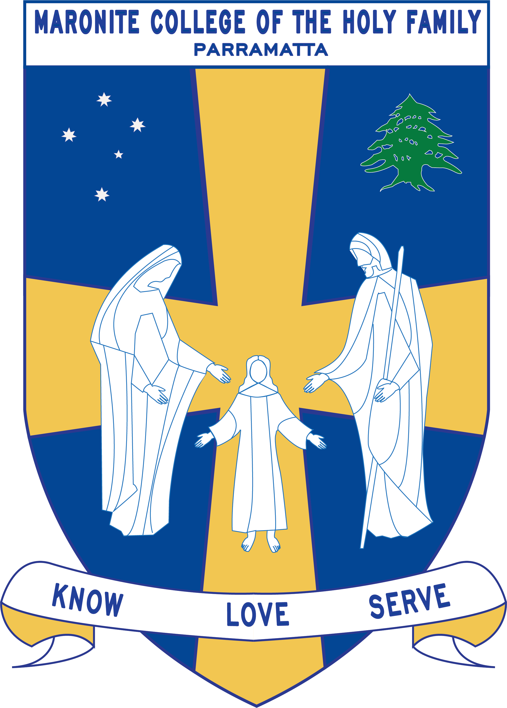
Howayek Providence Limited trading as
Maronite College of the Holy Family

Year 1 Term 3 Overview 2020

Dear Parents and Guardians,

Welcome to Term 3. Listed below is a summarised outline of the topics and content we will be covering in our grade. Information pertaining to all other aspects of the grade has also been included to help you organise and support your child’s learning.

We look forward to working in collaboration with you throughout this year.

Teaching Staff
Head of Primary | Mr Dean Day
Stage Coordinator K-2 | Mrs Vrontas
Class Teachers | Miss Njeim- 1 Silver  Miss Redden- 1 Lilac  Ms Khodeir-1 Gold  Ms Dibou- 1 Green
Special Needs Coordinator | Mr Christopher Perret
Integration Teacher/s | Mrs Pantaleone /Mrs Dagher
Teacher Assistant | Mrs El Asmar
Learning Centre Coordinator | Ms Anne LeMerle
Arabic Staff | Mrs Marie Zaiter  Mrs Laura Chalhoub  Mrs Francine Farah  Mrs Denise Fares

Daily Routines
Monday | All Year 1 - Sport Day – Wear Winter sport uniform  1 Green – Learning Centre  1 Lilac – Learning Centre and ICT  1 Silver – ICT  Arabic for all classes – 11:20-11:50
Tuesday | 1 Gold- Learning Centre  1 Silver- Learning Centre and Borrowing  1 Lilac- Borrowing  1 Green- ICT  Arabic for all classes – 11:20-11:50
Wednesday | 1 Green- Borrowing  1 Gold- Borrowing  Arabic for all classes – 11:20-11:50
Thursday | Arabic for all classes – 11:20-11:50
Friday | Arabic for all classes – 11:20-11:50

Important Information
- Student Absences – A note or medical certificate is required when a student is absent from school. For prolonged illness, notification to the main office is also required.
- Parent and Teacher Meetings - All communication with teachers is to be conducted via phone or email through the Primary Office. Alternatively, you can write a brief note for your child to pass on to their teacher. At no time should a parent approach another student or parent, either at school or outside the College grounds regarding an issue relating to their child. These issues must also be raised at the Main Office so that the situation can be referred to the appropriate staff member. Following the correct procedure will ensure that any concern is addressed promptly.
- Homework – Spelling, sent home Monday due back Friday, Reading Eggs & Maths Online

Curriculum Overview
Key Learning Areas | Unit Outline
Religion | Baptism:  - This unit presents Mark’s account of ‘Jesus and the Children’ (Mark 10:13-16). Through this story the students can experience Jesus as one who welcomes, loves and invites them into His family. In this story children are valued. They are people who enjoy a relationship with Jesus and the kingdom.  - The unit introduces Baptism as the sacrament of initiation into the Church community. The emphasis here is on sharing in the new life of Christ, the key symbols and actions used in the Rite of Baptism.  Jesus our Friend:  - This unit focuses on the concept of relationship – loving God and Neighbour. It begins with the children’s experience of friendship and broadens to the Christian way of relating to others. Love, forgiveness and gratitude are virtues shown by Jesus.  - The students will learn to show love, be grateful and forgive just as Jesus did. Students will demonstrate the qualities of being a good friend i.e. showing forgiveness and gratitude, like Jesus loves us  Maronite Aspects  Saint Charbel Feast Day 21st July  Transfiguration of Our Lord 6th August  Assumption of Our Lady 15th August  Exaltation of the Cross 14th September
English | Students will be engaged in the daily literacy block each morning where they will read, write, listen and talk. Quality independent tasks have been designed to reinforce the vocabulary and comprehension of the shared book.  - Participate in daily Guided Reading groups  - Build upon their personal bank of High Frequency words and use them in all literacy opportunities across all Key Learning Areas  - Develop the student’s vocabulary knowledge and spelling strategies of more complex words and their structures  - Develop skills of writing texts with a focus on Purpose and Audience, Sentence Structure and Editing.  - Recognise thematic words in their texts across all Key Learning Areas and apply them to their own daily use.  - Begin to make inferences based on information gathered from the text, used the text to make connections and build comprehension.  - Develop an understanding of self - monitoring when reading independently  - Engage in purposeful talk about their work and the shared reading text
Mathematics | Students will be engaged in daily maths activities that focus on the use of concrete materials to explore and informally record beginning maths concepts which include -  - Volume and Capacity  - Whole Number – Place value of two -digit numbers, representing two -digit numbers, ordinal numbers.  - Addition and Subtraction  - Multiplication and Division  - 2-Dimensional Shapes  - 3- Dimensional Shapes  - Chance
History/Geography/  Science & Technology | Features of Places- This unit focuses on natural and human features of places.  Students will:  - Describe the reasons places change and identify the active role of citizens in the care of places.  - Learn about how people describe the weather and seasons of places.  - Explore activities occurring in places and how the spaces within places can be used for different purposes.
Personal Development, Health and Physical Education | Health: ‘Why am I growing and changing?’  - Students investigate what changes may occur to them physically and socially across different contexts while considering how this may impact them emotionally. There is a strong focus on investigating the influence of family and friends upon their decisions related to their health and wellbeing  PE: ‘How can I further develop my movement skills?’  - Students participate in a wide variety of movement challenges and games to further develop fundamental and creative movement skills. They are encouraged to experiment with and integrate the skills of running, dodging and striking. Students learn through skill development in movement challenges and skill-based games.
Creative Arts | Visual Arts  - Photography, Print Making, Painting, Fibre, Sculpture and 3D.  - Objects- Symbols to tell a story. Aboriginal Art Works.  Music  - Dynamics, Tone Colour  - Taba Naba Song

