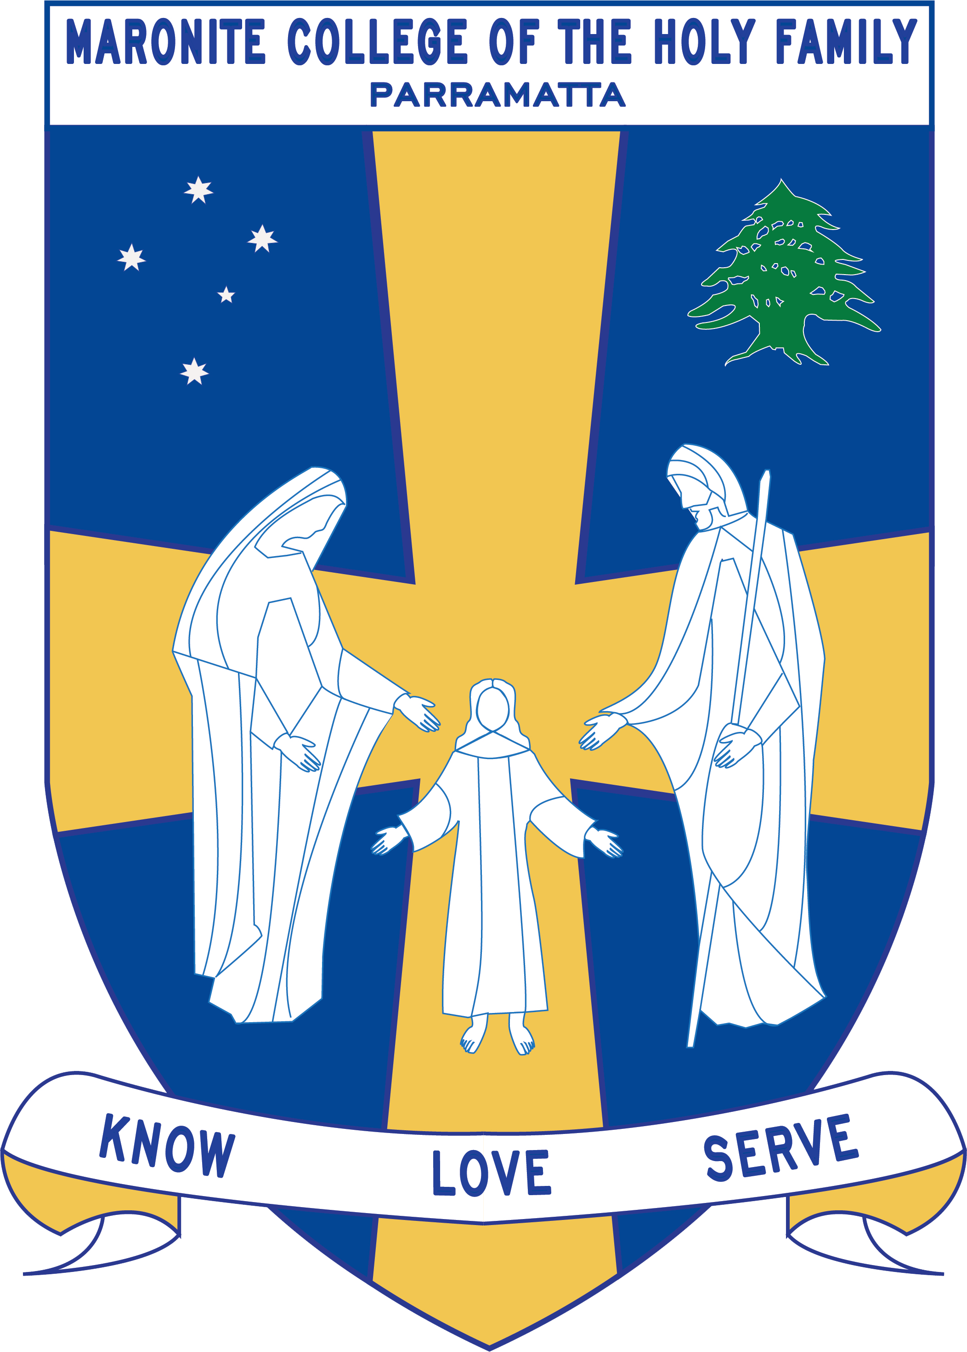
Howayek Providence Limited trading as
Maronite College of the Holy Family

Year 2 Term 3 Overview 2020

Dear Parents and Guardians,

Welcome to Term 3. Listed below is a summarised outline of the topics and content we will be covering in our grade. Information pertaining to all other aspects of the grade has also been included to help you organise and support your child’s learning.

We look forward to working in collaboration with you throughout year.

Teaching Staff
Head of Primary | Mr Dean Day
Stage Coordinator | Mrs Eugenia Vrontas
Class Teachers | Miss Rizk 2 Diamond  Mrs Taouk 2 Pink  Miss Homsy 2 Purple  Mrs Roumanus 2 Jade
Special Needs Coordinator | Mr Christopher Perret
Integration Teacher/s | Mrs Panteleone/ Mrs Dagher
Teacher Assistant | Mrs Zdrillic
Learning Centre Coordinator | Ms Anne LeMerle
Arabic Staff | Mrs Marie Zaiter  Mrs Laura Chalhoub  Mrs Francine Farah  Mrs Therese Sassine

Daily Routines
Monday | 2 Diamond: ICT/Library Borrowing  2 Purple: Library Borrowing  Arabic for all classes – 12:20-12:50
Tuesday | Year 2: Sport  Year 2 Pink: Library Borrowing/Library Skills/ICT  Arabic for all classes – 12:20-12:50
Wednesday | 2 Diamond: Library Skills  2 Jade: Library Borrowing /Library Skills  2 Purple: ICT/Library Skills  Arabic for all classes – 12:20-12:50
Thursday | 2 Jade: ICT  Arabic for all classes – 12:20-12:50
Friday | Arabic for all classes – 12:20-12:50

Important Information
- Student Absences – A note or medical certificate is required when a student is absent from school. For prolonged illness, notification to the main office is also required.
- Parent and Teacher Meetings - All communication with teachers is to be conducted via phone or email through the Primary Office. Alternatively, you can write a brief note for your child to pass on to their teacher. At no time should a parent approach another student or parent, either at school or outside the College grounds regarding an issue relating to their child. These issues must also be raised at the Main Office so that the situation can be referred to the appropriate staff member. Following the correct procedure will ensure that any concern is addressed promptly.

Curriculum Overview
Key Learning Area | Unit Outline
Religion | Caring for God’s Wondrous Creation  This unit focuses on living in right relationship with all of God’s creation. Through the parable of ‘The Good Samaritan’ children explore Jesus’ teaching about caring for others. Students explore the beauty and wonder of creation in Genesis 1:28-31 and their responsibility towards it. They will understand that by appreciating nature we come to know God and recognise the Divine presence in the wonder and work of creation.  Mission Loving God and others like Jesus  In this unit, students relate their experience of the loving actions of family members and others to the example of Jesus through a study of Jesus and the Blind Beggar and Jesus and Zacchaeus. Students will learn how Christians with a sense of mission can love God and others through their relationships with others at a personal, local and global level. Students will be encouraged to identify how they can participate in the mission of Jesus by loving God and other people in imitation of him.
English | Students will be engaged in the daily literacy block each morning where they will read, write, listen and talk. Quality independent tasks have been designed to reinforce the vocabulary and comprehension of the shared big book  - George's Marvellous Medicine, is the Shared Reading text.  - Daily Guided Reading sessions  - Independent reading and writing sessions to practice the skills taught  - Shared Reading tasks based on the literature presented to the students to explicitly teach comprehension strategies and behaviours when reading more complex texts.  - Modelled writing to explicitly teach writing quality narratives – purpose and audience, sentence structure, spelling strategies  - Introduced to note taking and its benefits  - Exposed to letter writing-writing a letter from one character to another  - Purposeful talk throughout the day to encourage students to communicate and listen efficiently  - Think, pair and share strategy used to teach listening and talking skills. This allows the students to share their thoughts and opinions
Mathematics | Term 3 Mathematics focuses: Money, Multiplication and Division, Time, Volume and Capacity and Chance.  Number and Algebra- Whole Numbers  Students will count and order small collections of Australian coins and notes according to their value, use the face value of coins and notes to sort, order and count money. They will compare Australian coins and notes with those from other countries, e.g. from students' cultural backgrounds. Determine whether there is enough money to buy an item. Recognise that there are 100 cents in $1, 200 cents in $2 etc, and identify equivalent values in collections of coins and in collections of notes  Measurement- Time  Students will tell time to the nearest minute and investigate the relationship between units of time. They will use the words ‘past’ and ‘to’ when telling time and record in words various times shown on analogue and digital clocks.  Number and Algebra- Multiplication and Division  Students will be recalling multiplication facts of 2, 3, 5 and 10 and related division facts. They will recognise and use symbols for multiplication and division. Students will link multiplication and division facts using arrays and will solve a variety of problems using effective mental and written strategies.  Measurement and Geometry- Volume & Capacity  Students will be learning about Measurement with the focus being on volume, informal units of volume and capacity, millilitres, litres, cubic centimetres and the volume of rectangular prisms.  Statistics and Probability- Chance  Students list all possible outcomes of everyday events, describe and compare chance events in social and experimental contexts.
History/Geography/  Science & Technology | History Topic: The Past in the Present  In this unit students study their local history.  - Students explore, recognise and appreciate the history of their community by examining the remains of the past in the present and considering why they should be preserved.  - Students identify continuity and changes in the daily life of the community using appropriate historical terms. They will relate stories about their families' and communities' past, exploring different point of views within a historical context. Students identify and describe significant people, events, places and sites in the local community over time.  - Students compare objects, technology and lifestyle from the past and present, building a richer picture of their local history. They will describe the effects of changing technology on people's lives over time, comparing their own lives to those of the past.
Personal Development, Health and Physical Education | Personal Development  ‘Wellbeing and Relationships’  Students explore qualities of good friendships, characteristics that make us unique and respectful behaviours. They will also participate in PE activities to build upon these skills.  ‘Why is food a jigsaw?’  Students explore how food can improve the health of everyone in their community. They explore how cultural differences influence food selection and the role food has within cultural celebrations. This unit has been designed to align with ‘Where have our games come from?’ as students discover cultural influences in food and physical activity.  Physical Education  ‘Where have our games come from?’  Students explore a wide variety of games from around the world as they discover “Where have our games come from?” They participate in games from various cultural backgrounds with a strong focus on Traditional Indigenous Games. This has been designed to align with the ‘Why is food a jigsaw?’ unit where students explore the influence of food on their health and how cultural traditions influence food selection with a strong focus on Aboriginal and Indigenous cultures.
Creative Arts | Visual arts and Drama  Students participate in Creative Arts as a way of expressing their imaginative visions.  - Students will participate in Musical activities for 2 weeks based on the rhythmic text “Giraffes Can’t Dance” This will be the inspiration for students composing their own Music and appreciation for the music of others and exploring the Musical concepts of Duration, Pitch and Dynamics.  - Students participate in Dance and Drama activities where they will need to create a short performance about ‘Safety.

