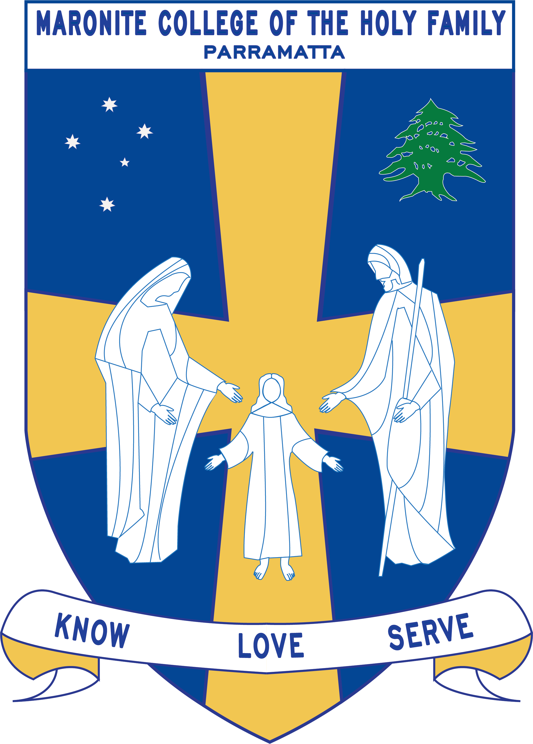
Howayek Providence Limited trading as
Maronite College of the Holy Family

Year 5 Term 3 Overview 2020

Dear Parents and Guardians,

Welcome to Term 3. Listed below is a summarised outline of the topics and content we will be covering in our grade. Information pertaining to all other aspects of the grade has also been included to help you organise and support your child’s learning.

We look forward to working in collaboration with you throughout year.

Teaching Staff
Head of Primary | Mr Dean Day
Stage Coordinator | Ms Rozario
Class Teachers | Ms Pillay – 5 Sapphire  Mrs Kartabani- 5 Rainbow  Mrs Guinan and Mrs Murphy – 5 Opal  Mrs Sadek – 5 Ruby
Special Needs Coordinator | Mr Christopher Perret
Integration Teacher/s | Mrs Maxwell
Support Teacher/s | Mrs Waffa Moussa
Learning Centre Coordinator | Ms Anne LeMerle
Arabic Staff | Mrs Marie Zaiter  Mrs Laura Chalhoub  Mrs Francine Farah  Mrs Therese Sassine

Daily Routines
Monday | Sport, Arabic
Tuesday | Arabic
Wednesday | Arabic
Thursday | Arabic, Library Borrowing (Rainbow)
Friday | Library Borrowing (Sapphire, Opal and Ruby)

Important Information
- Student Absences – A note or medical certificate is required when a student is absent from school. For prolonged illness, notification to the main office is also required.
- Parent and Teacher Meetings - All communication with teachers is to be conducted via phone or email through the Primary Office. Alternatively, you can write a brief note for your child to pass on to their teacher. At no time should a parent approach another student or parent, either at school or outside the College grounds regarding an issue relating to their child. These issues must also be raised at the Main Office so that the situation can be referred to the appropriate staff member. Following the correct procedure will ensure that any concern is addressed promptly

Curriculum Overview
Key Learning Area | Unit Outline
Religion | The Faith Communities in my local area:  By the end of this unit students should be able to:  - identify and research selected Christian churches in the local area  - recall key facts about the beliefs and communal life of the Anglican and Uniting Churches  - describe similarities and differences between the worship and ministries of the Catholic, Anglican and Uniting Churches  - list some of the ways in which Christians seek the unity Jesus prayed for.  Living the Message of Jesus:  By the end of this unit students should be able to:  - recognise that we are responsible for the decisions we make and their consequences  - identify and evaluate the ways in which people influence our decision making  - interpret and apply Scripture stories which challenge us to live Christian lives  - appreciate the different ways in which Christians can lead and serve others.
English | This terms program will have a focus on Refugees. We look at the text ‘Onion Tears’ by Dianna Kidd and relate themes and issues to letter writing skills and text connections to real life issues.  Students will be deconstructing and writing poems. The types of poems being explored during this unit will be ‘couplets’ and ‘ballads’. This will be the students writing assessment.  Students will explore features of informative texts through the study of deserts.
Mathematics | Whole number: Students will focus on factors and multiples of whole numbers. Students will use a Venn diagram to assist them in finding the highest common factor in two whole numbers. They will also use their problem-solving skills to answer word problems.  Number and Algebra: Students will rotate at different stations and apply skills learnt to continue number patterns and find missing numbers by looking at what information they already have.  Measurement & Geometry: Students will focus on identifying, naming and describing the properties of three –dimensional shapes. They will also use playdough and string in order to assist them in their knowledge of cross-sections of various 3D shapes.  Measurement & Geometry: Students will use formal algorithm to find the volume of various 3D shapes. They will rotate at stations where they will use their problem-solving skills to communicate and apply reasoning to their answers. They will work through word problems that involve finding the capacity of certain three-dimensional shapes.  Statistics & Probability: Students develop skills to determine the chance of certain outcomes and will use the correct terminology to describe whether an event is certain or impossible.
History/Geography/  Science & Technology | Students investigate how people change the natural environment in Australia and other places around the world. They also explore how the environment influences the human characteristics of places. Students examine ways people influence the characteristics of places, including the management of spaces. Students explore the impact bushfires have on Australian people, places and environments and propose ways people can reduce the impact of bushfires in the future.  During this unit, students will investigate the influence of the environment on the human characteristics of a place by comparing how people have responded to climatic conditions in similar and different places. Students will exam the effects of landforms on the location and characteristics of places.
Personal Development, Health and Physical Education | PDH - Students practice, perform and refine specialised movement skills within traditional and modified challenges. They self-reflect on their own strengths and use feedback to modify and adapt their performance.  PE – Students apply critical and creative thinking to solve movement challenges when participating in different games. They explore the roles of different team members in game play, participating cooperatively to achieve the team’s goal. Students participate in modified games of Ultimate Frisbee and soccer.
Creative Arts | Visual Arts: Students will study and look at examples of Aboriginal cross-hatching and create their own art-work using this same technique of their hand.  Drama: Student learn about drama concepts and use them to create an infomercial.  Music: Students focus on singing and music components. Student use these musical skills to create and perform lyrics to a song accompanied by a musical piece.

